|  |
| --- |
|  |
| Social Innovation as Valuation and Outcome Category of SNSF Funded Research |
| Report |

Zentrum für Soziale Innovation

May 2022

**Social Innovation as Valuation and Outcome Category of SNSF funded Research**

ZSI – Zentrum für Soziale Innovation

Suggested citation: Schuch, K., Lampert, D., Neuhuber, T. Koller, K., Demir, U. and L-A. Plumhans (2022). Social Innovation as Valuation and Outcome Category of SNSF funded Research. ZSI: Vienna.

Contact:

Klaus Schuch (schuch@zsi.at)

Linke Wienzeile 246

1150 Vienna

Austria

More information on the ZSI is available on the internet (www.zsi.at).

Vienna: Centre for Social Innovation, May 2022

Table of Content

1) EXECUTIVE SUMMARY 4

2) INTRODUCTION 4

2.1 Rational and background of this study 4

2.2 Study design and applied methods 4

3) SOCIAL INNOVATION AS A RESEARCH CATEGORY 5

3.1 Meaning of Social Innovation 5

3.2 Attributes of Social Innovation 5

4) SOCIAL INNOVATION IN SNSF PROJECTS 6

4.1 Familiarity and self-assessment – a first approximation 6

4.2 Extent of transdisciplinarity in SNSF funded projects 10

4.3 Productive interactions: Obstacles and attempted solutions 17

5) NEW SOCIAL PRACTICES? OUTCOMES AND LIMITATIONS 17

5.1 Motivation and intended social innovation outcomes 17

5.2 Actual outcomes and limitations 25

6) the last miles ON THE ROAD TO IMPACT 32

7) WRAP-UP 1: VALUATION of social innovation as potential outcome category of SNSF funded research 32

8) WRAP-UP 2: TOWARDS A MODEL OF ASSESSING snsf’ CONTRIBUTION TO SOCIAL INNOVATIONS 32

9) LITERATURE 33

10) ANNEX 36

**List of Tables**

Table 1**: Analytical dimensions to identify social innovations** 6

**List of Figures**

Figure 1: **Overview on the Research Design** 5

Figure 3: **Multi-method approach** 6

Figure 2**: R&D phases and procedures for social innovation research** 7

1. EXECUTIVE SUMMARY

Our proposal aims to trace contributions of research funded by SNSF to social innovations, and to systematise these contributions in a valuation framework. In addition, we aim to identify to what extent contributions to social innovation in SNSF-funded research projects are possible at all, and where further support measures, either provided by SNSF or from outside (e.g. by the universities), could create an added value that could not be tapped so far.

1. INTRODUCTION

2.1 Rational and background of this study

Our proposal aims to trace contributions of research funded by SNSF to social innovations, and to systematise these contributions in a valuation framework. In addition, we aim to identify to what extent contributions to social innovation in SNSF-funded research projects are possible at all, and where further support measures, either provided by SNSF or from outside (e.g. by the universities), could create an added value that could not be tapped so far.

2.2 Study design and applied methods

Our proposal aims to trace contributions of research funded by SNSF to social innovations, and to systematise these contributions in a valuation framework. In addition, we aim to identify to what extent contributions to social innovation in SNSF-funded research projects are possible at all, and where further support measures, either provided by SNSF or from outside (e.g. by the universities), could create an added value that could not be tapped so far.

Figure 1: **Overview on the Research Design**

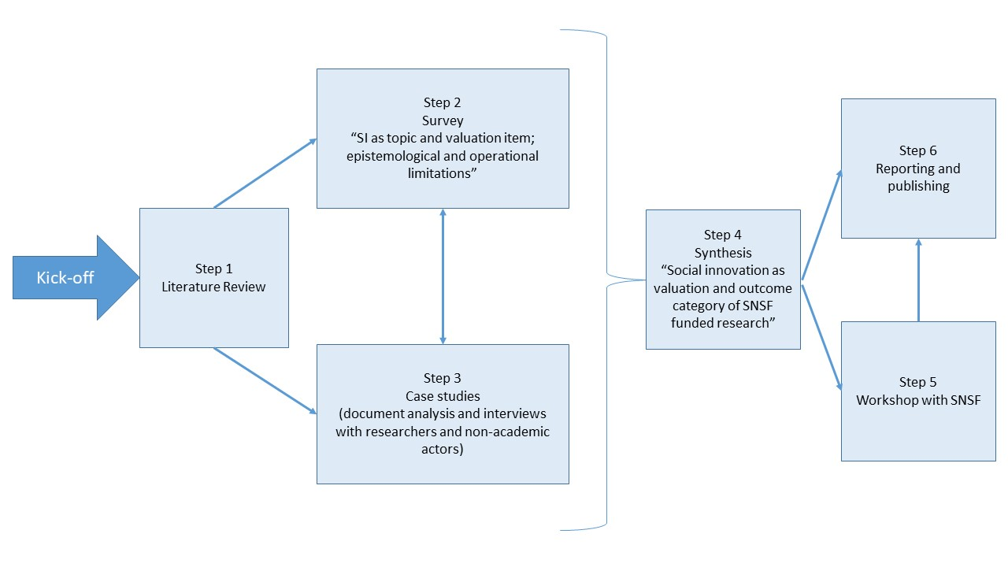

Source: Own illustration

Our proposal aims to trace contributions of research funded by SNSF to social innovations, and to systematise these contributions in a valuation framework. In addition, we aim to identify to what extent contributions to social innovation in SNSF-funded research projects are possible at all, and where further support measures, either provided by SNSF or from outside (e.g. by the universities), could create an added value that could not be tapped so far.

Figure 2: **Multi-method approach**

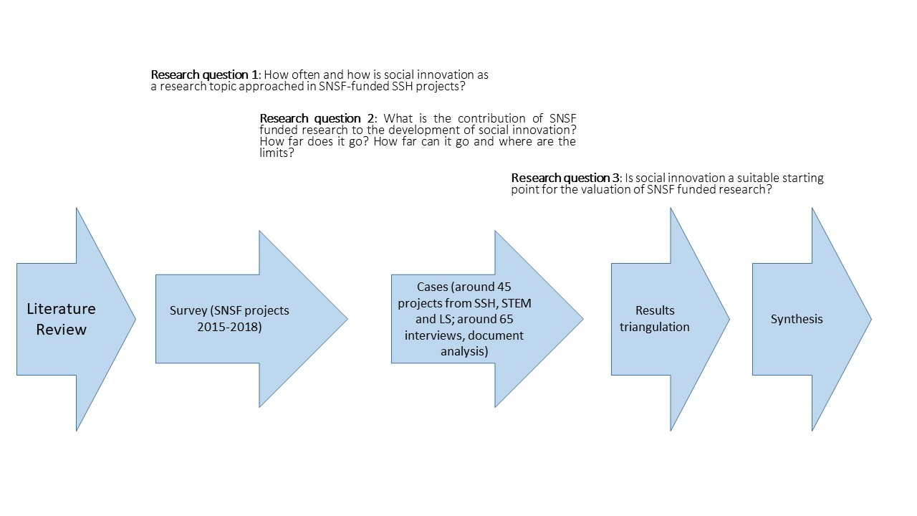

Source: own illustration

1. SOCIAL INNOVATION AS A RESEARCH CATEGORY

3.1 Meaning of Social Innovation

Our proposal aims to trace contributions of research funded by SNSF to social innovations, and to systematise these contributions in a valuation framework. In addition, we aim to identify to what extent contributions to social innovation in SNSF-funded research projects are possible at all, and where further support measures, either provided by SNSF or from outside (e.g. by the universities), could create an added value that could not be tapped so far.

3.2 Attributes of Social Innovation

Our proposal aims to trace contributions of research funded by SNSF to social innovations, and to systematise these contributions in a valuation framework. In addition, we aim to identify to what extent contributions to social innovation in SNSF-funded research projects are possible at all, and where further support measures, either provided by SNSF or from outside (e.g. by the universities), could create an added value that could not be tapped so far.

Table 1**: Analytical dimensions to identify social innovations**

|  |  |
| --- | --- |
| Analytical dimensions | 1. Social innovation results in a *changed social practice* (= object of a social innovation). |
| 1. A social innovation must be *new in a specific context or for a specific actor.* |
| 1. A social innovation is *developed to fulfil a social purpose* in that sense that it aims to better cope with needs and problems than is possible by using existing practices |
| 1. Social innovations are *intentionally solution-oriented* *and prompted by actors or a constellation of actors*. They do not just happen and they are not the same as social change, but they can contribute to it. |
| 1. A social innovation is more than an idea and must be *put into practice* (i.e. difference between idea, invention and innovation in analogy with techno-economic innovation) |

Source: XYZ

Our proposal aims to trace contributions of research funded by SNSF to social innovations, and to systematise these contributions in a valuation framework. In addition, we aim to identify to what extent contributions to social innovation in SNSF-funded research projects are possible at all, and where further support measures, either provided by SNSF or from outside (e.g. by the universities), could create an added value that could not be tapped so far.

1. SOCIAL INNOVATION IN SNSF PROJECTS

4.1 Familiarity and self-assessment – a first approximation

Our proposal aims to trace contributions of research funded by SNSF to social innovations, and to systematise these contributions in a valuation framework. In addition, we aim to identify to what extent contributions to social innovation in SNSF-funded research projects are possible at all, and where further support measures, either provided by SNSF or from outside (e.g. by the universities), could create an added value that could not be tapped so far.

Familiarity and self-assessment were also building blocks of the questionnaire, both of the concepts have been directed to the participants in the same question group with the assessment of experience with the transdisciplinary research. These variables will be vital in the hypothesis testing, as they reflect the respondent’s view on their own competencies and achievements, a self-assessment that can then be contrasted with their responses on other potential key factors, such as the project’s non-academic outcomes or the inclusion of non-academic actors in their SNSF funded projects. More information on the testing of the hypotheses can be found in chapter 4; this chapter shows first the results of the descriptive statistics.

The first variable to analyse in this group of question is *experience with* *transdisciplinary research*. There are several ways to approach the concept of transdisciplinarity. In the context of this study, we refer to the Swiss Academy of Sciences who understands[1] *transdisciplinary research* as research linking “[…] *societal problem solving with scientific knowledge production in a process of co-producing knowledge*.”

Scholarly literature goes as far as stating that *transdisciplinary aspects* are central (and necessary) to SI-related research. Thus, it could be argued that *transdisciplinarity* ought to be regarded as a potentially important indicator for SI-relevant outcomes. In contrast to this notion, however, our theoretical framework does not consider *transdisciplinary involvement* a necessary prerequisite for research projects to contribute to SI. That said, we still expect it to be more influential than other factors (for a more detailed exploration, see Section ).

When asked about their ***experience with transdisciplinary research***, 48 % of respondents stated that they are indeed experienced (7 and above on a 0-10 scale; 10 being the maximum), 26 % replied to be somewhat experienced, and another 26 % that they were not experienced (3 and below; 0 being the minimum). Figure 3 (first row) provides a visual overview on this distribution, while Table 2 (left columns) details all the responses in each category separately. The latter also shows that, out of 361 overall survey participants, 352 chose to answer this particular question, while 9 refrained from answering.

Figure 3: SI-familiarity, familiarity with transdisciplinarity, and project’s contribution to SI (self-assessment)

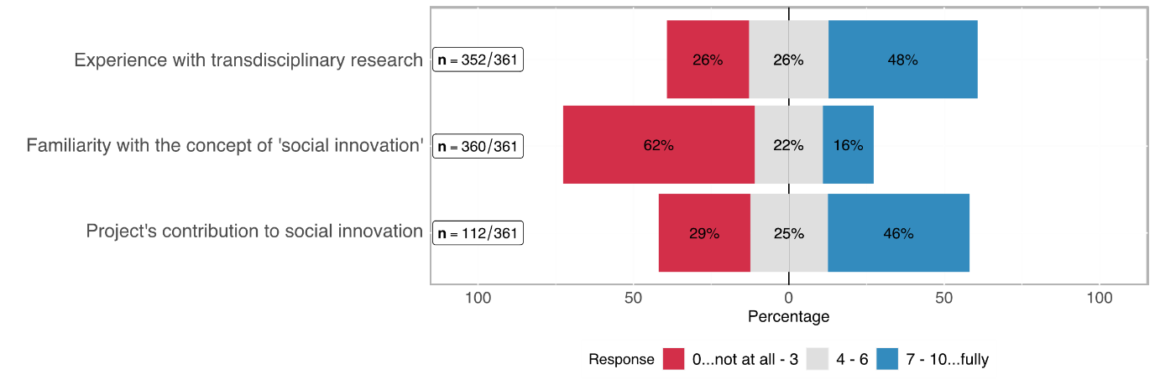

Table 2: Self-assessment in terms of transdisciplinary experience, familiarity with SI, project's contribution to SI

|  |  |  |  |  |  |  |
| --- | --- | --- | --- | --- | --- | --- |
| **Rating** | **Transdisciplinary experience**  **(n = 352)** | | **Familiarity with SI**  **(n = 360)** | | **Project's contribution to SI**  **(n = 112)** | |
| ***0..lowest***  ***10..highest*** | abs | % | abs | % | abs | % |
| **0** | 19 | 5.26% | 116 | 32.22% | 5 | 4.46% |
| **1** | 17 | 4.71% | 36 | 10.00% | 3 | 2.68% |
| **2** | 26 | 7.20% | 33 | 9.17% | 12 | 10.71% |
| **3** | 31 | 8.59% | 37 | 10.28% | 13 | 11.61% |
| **4** | 21 | 5.82% | 25 | 6.94% | 7 | 6.25% |
| **5** | 37 | 10.25% | 37 | 10.28% | 13 | 11.61% |
| **6** | 32 | 8.86% | 17 | 4.72% | 8 | 7.14% |
| **7** | 58 | 16.07% | 19 | 5.28% | 17 | 15.18% |
| **8** | 40 | 11.08% | 20 | 5.56% | 22 | 19.64% |
| **9** | 27 | 7.48% | 6 | 1.67% | 6 | 5.36% |
| **10** | 44 | 12.19% | 14 | 3.89% | 6 | 5.36% |
| **no response** | *9* |  | *0* |  | *1* |  |

As regards the ***familiarity with SI***, 360 participants responded. 62 % of whom stated to be *not at all* to *barely* familiar with the idea of SI (3 and below on a 0-10 scale), roughly 22 % consider themselves as moderately familiar (4-6 on that scale), and 16 % as *familiar* to *highly familiar*. Figure 3 (second row) provides a visual overview on this distribution, while Table 2 (centre columns) details all the responses in each category separately.

This variable is particularly interesting when further analysing whether researchers from a scientific domain are more familiar with the concept than researchers from another scientific domain –Section Error: Reference source not found answers this question. Overall, we can summarise that a rudimentary conceptual understanding of SI not (yet) common sense in the scientific world.

Out of the 113 *eligible*[2] participants, i. e. those who believe to be at least moderately familiar with SI, 112 chose to answer the question regarding their ***project’s contribution to SI*** (see bottom row of Figure 3 above). Of those, 29 % stated that their project contributed little to nothing to SI, while 46 % stated that it was high to very high.

SI is a relatively little-known concept among most of the survey respondents as described above. The question is, though, whether there is a difference between scientific domains when it comes to the familiarity of researchers with the concept of SI.

The distribution of participants across the three domains is balanced, each represents roughly one third of the overall number of participants (cf. Error: Reference source not found). As Figure 4 and Table 2 Show, the share of researchers from the Humanities and Social Sciences increases with each higher degree of *familiarity with SI* while the share of the other two domains dwindles in comparison.

This observation corresponds with our expectations and will further be examined in the hypothesis chapter in section Error: Reference source not found (pp. Error: Reference source not found) of the chapter on hypotheses.

Figure 4: Distribution of the familiarity with SI

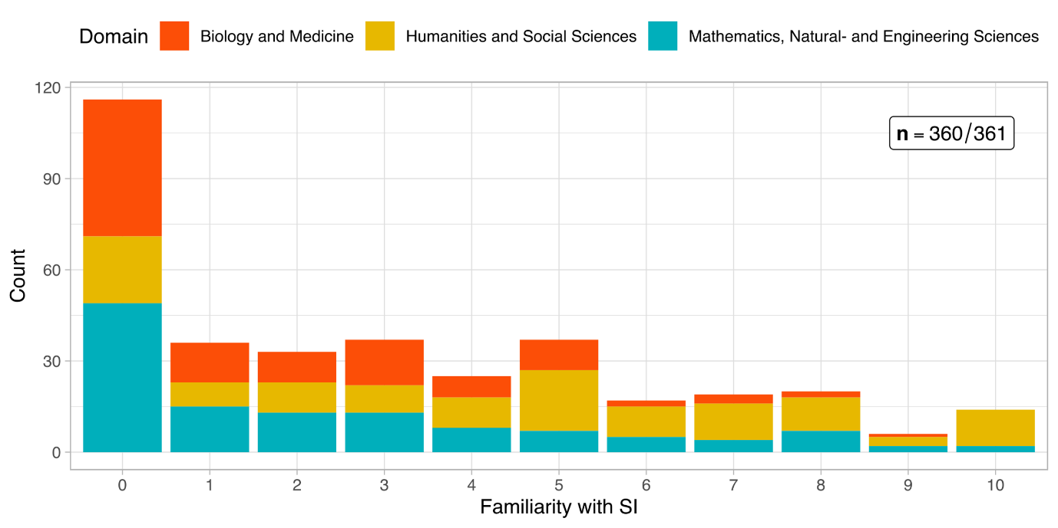

Respondents were asked about their project’s contribution to SI as a control variable, firstly, to scrutinise the relationship between the self-assessment and a model-driven SI-Index[3], and secondly, to conclude if the self-assessment was generally overestimated. As the figure below and Table 2 show, there is no clear distribution across the offered rating spectrum.

Figure 5: Distribution of self-assessed SI-Contribution

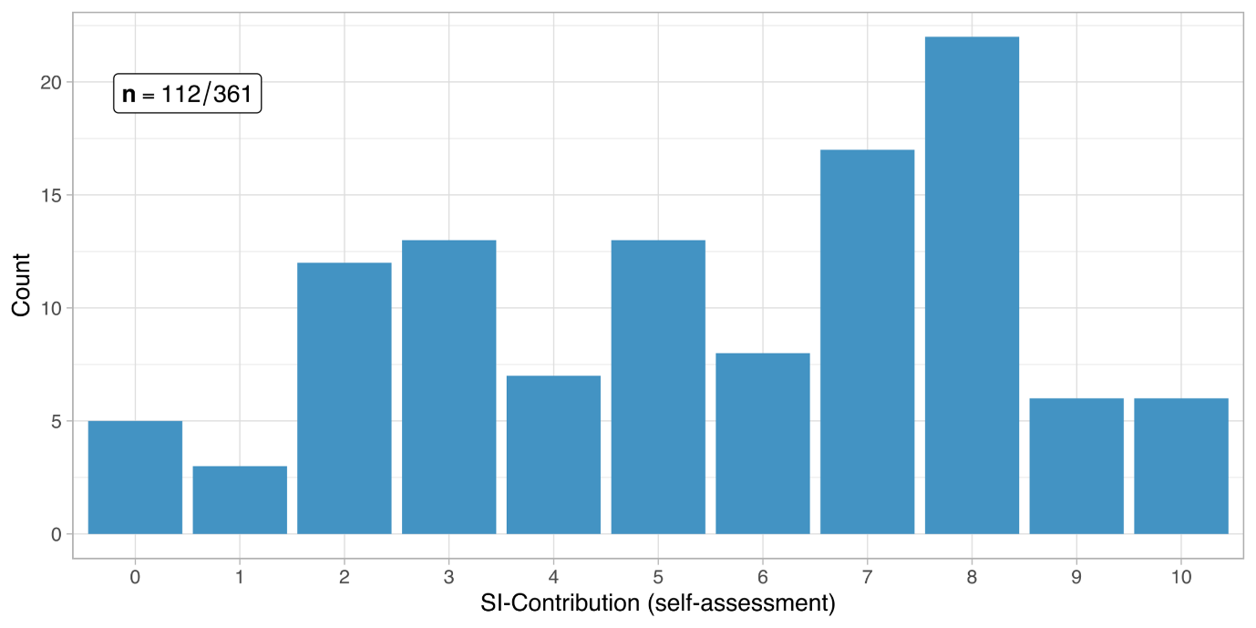

4.2 Extent of transdisciplinarity in SNSF funded projects

Respondents’ experience with transdisciplinary research and age

This sub-section follows up on the question, whether the respondents’ *age* had anything to do with their *experience with transdisciplinary research*. Figure 6 shows the distribution of the transdisciplinary experience on the x-axis (0..10 from lowest to highest), while the age groups are shown on the y-axis. Some variance is noticeable but a general trend is not visible. Even the younger age groups are spread across a low to a high degree of transdisciplinary experience.

Chapter Error: Reference source not found (pp. Error: Reference source not found) examines interesting potential correlations but, as a sneak preview, we can already say that this one is not among them, because the two variables “age” and “transdisciplinary experience” do not correlate strongly enough to be considered important factors contributing to SI.

Figure 6: Distribution of the transdisciplinary experience across age groups

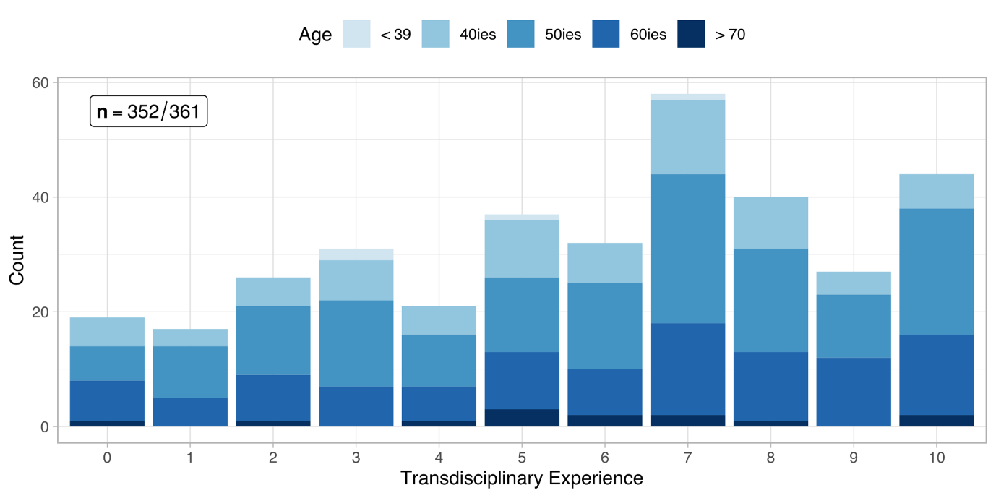

Figure 7**: R&D phases and procedures for social innovation research**

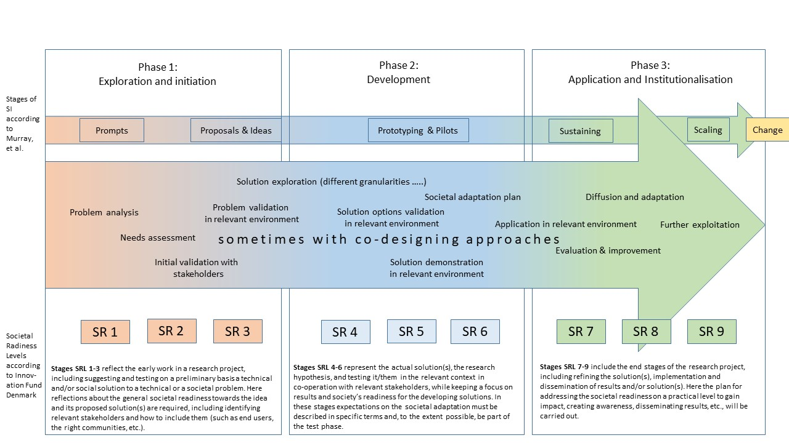

Source: Own illustration based on the stages of SI according to Murray et al. (2010) and the Societal Readiness Levels Concept of the Innovation Fund Denmark.

We differentiate between three project phases. Firstly, the proposal phase is defined as the stage during which the project plan is developed, and the application to the SNSF is initiated. Sometimes, exchanges went back to the time when the concrete project idea was not mature. Yet, some of these interactions then proved to be invaluable for the project outline and the subsequent execution. The second phase is the implementation phase. This stage refers to the period where a project has already started and tasks aimed at achieving the projects’ objectives, i.e. data collection, are undertaken. The third and last phase of a project is the exploitation phase, where results are made usable (e.g., by patenting) and dissemination activities are carried out.

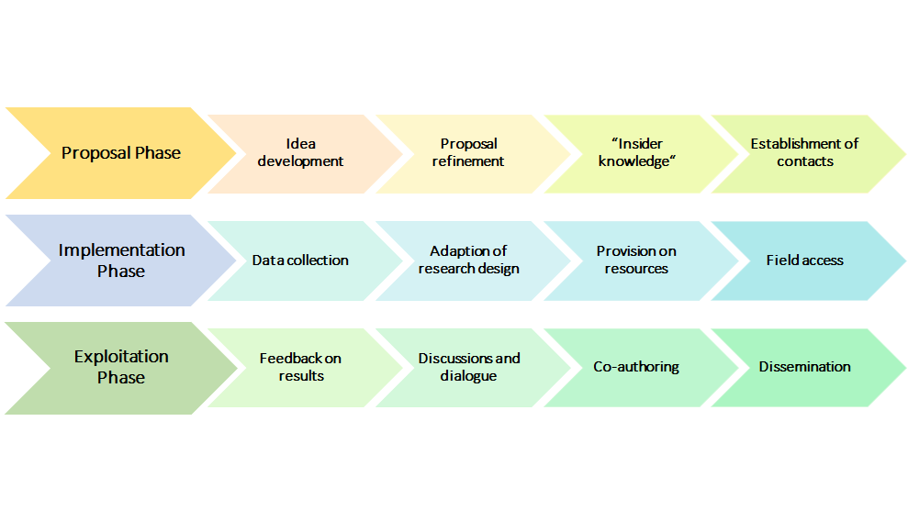

Most interviewees (~80 per cent) reported interactions with non-academic actors. Most often, this transdisciplinary design was intentionally included in the research design. However, in some cases, the communication and exchange with actors outside of academia emerged during the research implementation, i.e., interviewees noticed that a particular aspect of the issue can only be solved in conjuncture with others. However, there were also cases where the exchange took only place with other researchers.

1. **Media:** Interactions with the media mostly occurred during the exploitation phase. In most cases, this happened incrementally instead of being planned as a part of the research project. Interviewees highlighted that in order to reach a wider audience, it is crucial to publish in non-academic outlets. However, as already discussed, exchanges with media can also be problematic since a researcher has less control over what is being said. One interviewee mentioned that although he wanted to raise awareness amongst society, he tried to communicate the outcomes in a very neutral way.

*“I think, in everything that I said, I try always to stick very closely to what we have done in our study and what findings we have. I think that was helpful in the sense that, I was not commenting on some general refugee issues, but “this is the study we have conducted. It has all these limitations, but that is what we found.” And that minimises the risk of being instrumentalised from any party.” Interviewee 6*

One interviewee highlighted that it is helpful to know someone who works at a media outlet and to, hence, develop a network of reporters. This way, researchers can benefit from a greater involvement and can thus be ascertained that their findings are communicated in a value-free way. Furthermore, it was emphasized that researchers often are not skilled in communicating with the public, i.e., they use too scientific vocabulary and miss rhetorical skills. Hence, working together with journalists can both extend the audience as well as communication skills.

Other researchers also spoke to outlets that are aimed toward certain target groups. For example, one interviewee reported that he talked to a university magazine which had two main advantages. Firstly, this channel operates on a less normative basis and communicates more value-free than certain daily newspapers. Secondly, it is aimed at students who hence get the opportunity to read about the research that was undertaken at the university. This can help arouse interest for research projects amongst students in general as well as communicate subject-relevant information without the learning character of classes.

Only one interviewee reported that interactions with the media took place before the exploitation phase of the Project. Accordingly, his team worked together with journalists in order to recruit people for their experiment.

1. **Target group:** Exchanges with a project’s target group mostly happened during the implementation phase. Most often, target groups were included in the project through data collection (e.g., interviews or surveys). However, the degree of inclusion differed greatly between projects. While some project teams talked to their target group solely for the purpose of data acquisition, others continued working with them throughout the project. More specifically, several interview partners emphasized the need to empower the target group and ensure that they are heard by relevant stakeholders, i.e., practitioners and policy-makers. Yet, all interviewees who worked with their target group, stressed that it is absolutely crucial to talk to affected people when writing about them. Otherwise, one interviewee expressed that social science misses its goal to deliver outcomes that are as close to the reality of those affected as possible. Nonetheless, other researchers who did not have a social science background stressed something very similar. Correspondingly, one researcher coming from natural science highlighted that as soon as science affects one or several groups of people, they should be given a chance to participate in the project and express themselves.

Some interview partners also mentioned interactions with target groups in the proposal phase. For example, one PI recounted that before the project started, his team talked to acquaintances who could be possible participants of the project in order to better understand the phenomenon. Accordingly, this enabled the researchers to adapt the proposal as well as to refer back to an already existing pool of participants, which saved time during the project implementation phase.

In a few circumstances, the target group was also included in the exploitation phase of a project. One interviewee, for example, reported that she consulted her target group while simultaneously talking to practitioners and decision-makers in order to assure that the target group does not get misrepresented. Another interview partner reported that his team included participants in the writing process:

*“[A]s regards the extracts from interviews that we inserted into scientific productions, we always sent the articles back to the people concerned. They had the whole article, not just their quotes, and we told them that's what we said, and some of them gave us feedback on their quotes but also on the article itself, by providing clarifications, explaining such and such a thing that they thought we might have misunderstood. It's very interesting because we're used to feedback from colleagues, everyone knows that, it's very interesting too, but the fact that we also have feedback from the actors themselves is quite interesting.” Interviewee 7*

1. **Practitioners:** Practitioners were included in all project phases. Some PIs reported that they talked to practitioners in the proposal phase in order to ensure their participation in the later stages of the project. Moreover, it was highlighted that practitioners can contribute to the proposal by expressing their more applied and practical knowledge. This brings several benefits to the project. First, the proposal incorporates several perspectives making the propositions more holistic. Second, it increases the chances of the proposal as funding organisations often value a transdisciplinary research design. Third, it makes the undertakings more applicable to “the real world” and, subsequently, outcomes more usable for experts outside academia. Fourth, practitioners can give valuable feedback to a proposal which enables researchers to make necessary adjustments. For example, one interviewee who spoke to a Swiss association for retirement during the proposal phase noted that this exchange improved her proposal significantly and helped to sharpen her research question. Fifth, it might change the direction of a research project more drastically as practitioners raise researcher’s attention to certain problems that appear in their work. Hence, early interactions with practitioners can also benefit scientific research as their experiences might touch upon issues that have hardly been considered in research so far.

Further, several interview partners highlighted the continuous contact with practitioners, which allows them to revert to a network of praxis partners who might be interested in conducting projects together. Lastly, exchanges during the proposal phase of projects can facilitate later access to the field as practitioners might have contacts they can pass on and can hence, act as gatekeepers.

In many cases, practitioners were also consulted during the implementation phase. For instance, practitioners helped with data collection either directly by participating in interviews or indirectly by providing secondary data. In other contexts, practitioners supported researchers with the planning and refinement of their method (e.g., drafting questions for surveys). There were also interactions beyond the immediate data collection and analysis phase. One interviewee highlighted that there are continuous feedback loops with practitioners after the data has been collected:

*“So, perhaps it should be said that during the project, we are not in an approach where we come to the field, we collect the data and we leave. When the data is collected, there is also a whole restitution process which takes place during the project. Every three or four months. Afterwards, it depends on the project. The idea is: during the course of the project, between the beginning, the collection of data and the end of the analysis, there are moments of intermediate feedback. We are also in the process of giving the teams our understanding, our working hypotheses and how we understand them. If they don't validate, we say to ourselves that there is something we haven't understood. So, participation is important. It is really important.” Interviewee 1*

Generally, a lot of interview partners said that there were interactions with practitioners in the exploitation phase and even after the end of the project. In many cases, these exchanges took place within the scope of conferences or events where findings are presented and discussed. In some circumstances, feedback regarding the interpretation of results was also obtained. One interviewee claimed that when he discussed the outcomes of the project, praxis partners provided criticism and their perceptions which partly changed his view of the results. Generally, contact with practitioners during the exploitation phase seems to foster discussions and dialogue. Five interviewees mentioned that they included professionals in the writing process, for example, as co-authors of scientific publications. One interviewee claimed that this also helps with dissemination outside academia because practitioners carry project outcomes into their specific fields and communicate them to other professionals in the field.

While in most circumstances, interactions with practitioners prevailed throughout the course of the projects, some PIs said that interactions with new practitioners took place at the end of their projects. For example, one researcher said that once the results of the project were available, the project team approached practitioners directly in order to share insights and provide data.

1. **Industry/Businesses:** Only natural science projects exhibited exchanges with companies or industry representatives. Correspondingly, six interviewees reported that they reached out to businesses. Mostly, these interactions took place in the exploitation phase. All of those interview partners who communicated with industries claimed that in their field, it is essential to build relationships with industrial partners in order to make project results usable outside academia. A few interviewees also claimed that in order to make a project usable, commercialisation is crucial.

However, this is only possible with the support of industry partners and, more specifically, with larger investments.

Generally, all of these five interview partners claimed that there are still ongoing collaborations or exchanges with their industry partners. In some cases, research agreements were made after the project ended. Such agreements benefit both sides as researchers are guaranteed further funding for their research, and businesses benefit from research undertaken in their niche. However, it is underlined that such agreements can be difficult and time-consuming to negotiate and do not always succeed.

Another aspect is the explicit search for investors or venture capitalists. One interviewee, for example, reported that after the successful end of his project, he wanted to make his product more accessible by entering the market. In order to make his product ready for the market, he needed considerable investments, which he hoped to get by specifically approaching businesses.

Some of these interviewees also mentioned exchanges during the implementation phase. These interactions comprised mainly the provision of resource and technical discussions. It was highlighted that most often, links to industries are already established when working in a field for several years. Hence, interviewees referred to a “successful synergy” between researchers and companies who continuously work together and benefit from the resources and knowledge of the respective partner.

1. **Other researchers:** Many interviewees reported interactions with other researchers during the proposal phase. For example, one PI highlighted that in order to better understand the issue at stake, it was crucial to incorporate different perspectives early on. While in some cases, other researchers were only consolidated during this stage, others worked on the proposal collaboratively. Further, it was noted that the proposal phase is also vital for building a consortium of research partners. According to several interviewees, if the research design is supposed to be interdisciplinary, collaboration with other researchers should begin during the proposal phase. This ensures that competencies are mobilised, and research partners have the chance to get to know each other as early as possible.

Interactions during the implementation phase can be divided into two main categories. Firstly, some exchanges were limited to discussions at infrequent meetings. In these cases, the goal of the exchange was to share and examine preliminary results with other researchers who were otherwise not involved in the project. Contrarily, some interactions took place more synergistically, mostly with researchers who participated directly in the project. In this respect, meetings took place more frequently where updates and feedback were provided more in detail.

During the exploitation stage, formal interactions with other researchers happened mostly at conferences or other events. Some interviewees also mentioned that apart from conferences, they approached or were approached by other researchers with the objective of future research collaborations.

When it comes to informal exchanges, interviewees stressed that they talked a lot to colleagues from the same organisations, which in many cases also proved to be fruitful for further cooperation and knowledge transfer.

1. **Citizens:** All interactions with citizens or the wider society took place during the exploitation phase. In almost all cases where exchanges with citizens were identified, these interactions happened within the scope of non-scientific conferences or conventions. Hence, most projects that included citizens in their project did so by disseminating project results at specific events. One interviewee reported that his project team engaged in discussions with citizens not only at public events but also in everyday life. The aim of these discussions was to raise awareness of the research topic and to get insights into the public’s perspectives.
2. **Political actors and policy-makers:** Almost 75 per cent of interviewees interacted with policy-makers at some stage of their project. During the proposal phase, most interactions regarded the presentation of the project idea and discussions for further collaboration. One interviewee mentioned that she found it essential to include decision-makers early on and to keep them updated about the project in order to achieve a shift in perspectives. Similarly, others highlighted that interactions with policy-makers were useful to prove the practice-relevance of the project idea and to get people on board who are directly confronted with specific issues. Another interview partner claimed that policy-makers are essential to promote the project and its implementation in a larger context which is why they should already be involved in the proposal phase.

During the implementation phase, interactions were more restricted than in the previous project stage. However, three main matters can be identified. First, some researchers engaged with policy-makers for feedback reasons. More specifically, interactions took place in order to provide updates to political actors and to obtain guidance and recommendations. Second, policy-makers were contacted with the aim of receiving resources or data. And lastly, decision-makers were actively involved in the data collection process, e.g., by participating in interviews.

In the dissemination phase of the projects, interactions mostly took place in the form of presentations. While this is an important aspect of dissemination, one interviewee stressed that the informal aspects of such meetings are almost more important than the formal ones. Accordingly, coffee breaks are helpful to widen one’s network, talk about more details of the project as well as discuss further collaborations. In some cases, the dissemination only occurred through the delivery of a report which, according to two interview partners, reduced the impact the results could have. Other interviewees stressed that while there was indicated interest of policy-makers at earlier stages of the projects, no final meetings were scheduled.

1. **NGOs, civil actors, interest groups:** Ten interviewees reported interactions with either NGOs, civil actors or interest groups. While most of these exchanges happened during the later stages of the projects, some PIs contacted this stakeholder group before the official start of the project. Accordingly, two interviewees stressed that communication with NGOs during the finalisation of the proposal was crucial for the idea development. Another interviewee said that he contacted an NGO in order to ensure further cooperation within the project framework, which then ultimately led to a collaboration agreement.

After the proposal phase, NGOs and civil actors were included in the projects mainly in two aspects. Firstly, they provided field access to the research teams. This was especially important for projects that worked with vulnerable groups or that were implemented in other (mostly developing) countries. Accordingly, NGOs operate on a very low level and know the field very well. This enables researchers that come from different backgrounds to acquire knowledge about the specific context as well as to build a relationship with people from the field. Secondly, NGOs were also consolidated for data collection (e.g., field studies, interviews) purposes and participation in workshops. Beyond these two main objectives of interactions during the implementation phase, a few interviewees also stressed the continuous feedback they got from NGOs. This led to the refinement of the project idea and sharpened the implementation plan.

During the exploitation phase, exchanges with NGOs, civil actors and interest groups mainly involved the dissemination of results at conferences or meetings. While most of these interactions ended after the project completion, two interviewees underlined that there are still ongoing collaborations with NGOs.

1. **Institutions/organisations:** Lastly, institutions and organisations were identified as actors within the projects. These institutions and organisations were: foundations, associations and museums. However, interactions with this stakeholder group were only minor. Accordingly, two interviewees reported that they contacted associations operating in their field during the proposal phase in order to receive contacts from other stakeholders (e.g., the target group). Another interview partner mentioned that he used the interactions with an association for the revision of his proposal. Generally, there were no exchanges with such institutions or organisations during the implementation phase. During the final stage of the projects, some interviewees consolidated foundations and museums in order to circulate their findings.

4.2.1 Inclusion of stakeholders in the pre-project implementation phase

Our proposal aims to trace contributions of research funded by SNSF to social innovations, and to systematise these contributions in a valuation framework. In addition, we aim to identify to what extent contributions to social innovation in SNSF-funded research projects are possible at all, and where further support measures, either provided by SNSF or from outside (e.g. by the universities), could create an added value that could not be tapped so far.

4.2.2 Inclusion of stakeholders in the project implementation phase

Our proposal aims to trace contributions of research funded by SNSF to social innovations, and to systematise these contributions in a valuation framework. In addition, we aim to identify to what extent contributions to social innovation in SNSF-funded research projects are possible at all, and where further support measures, either provided by SNSF or from outside (e.g. by the universities), could create an added value that could not be tapped so far.

Level and nature of inter-/transdisciplinary involvement

Interdisciplinary cooperation is common among the SNSF funded projects. 41 % of the respondents note that the involvement of academicians from other disciplines was quite central to their specific project (see Figure 8). In total 78 % of the projects were carried out in collaboration with researchers from other disciplines (see Table 3).

*Transdisciplinary involvement* has been measured via categories which indicate the inclusion of different types of societal actors and groups in the research process. Although by far not as central as the interdisciplinary cooperation, different types of transdisciplinary engagement constitute a noteworthy part of the research projects. Transdisciplinary involvement types such as *involvement of citizens*, *involvement of policy makers/public administration*, *involvement of institutions providing welfare or education*, or *involvement of companies*, yield somewhat similar distributions among the projects of the survey respondents (22 % - 27 % of involvement rated above 3; 0 being minimum and 10 the maximum). An exception to this rather equal distribution is media, which was quite often involved in SNSF projects, but rarely centrally. Thus, we assume that media was mainly involved for pure dissemination purposes.

Figure 8: Level of interdisciplinary and transdisciplinary involvement

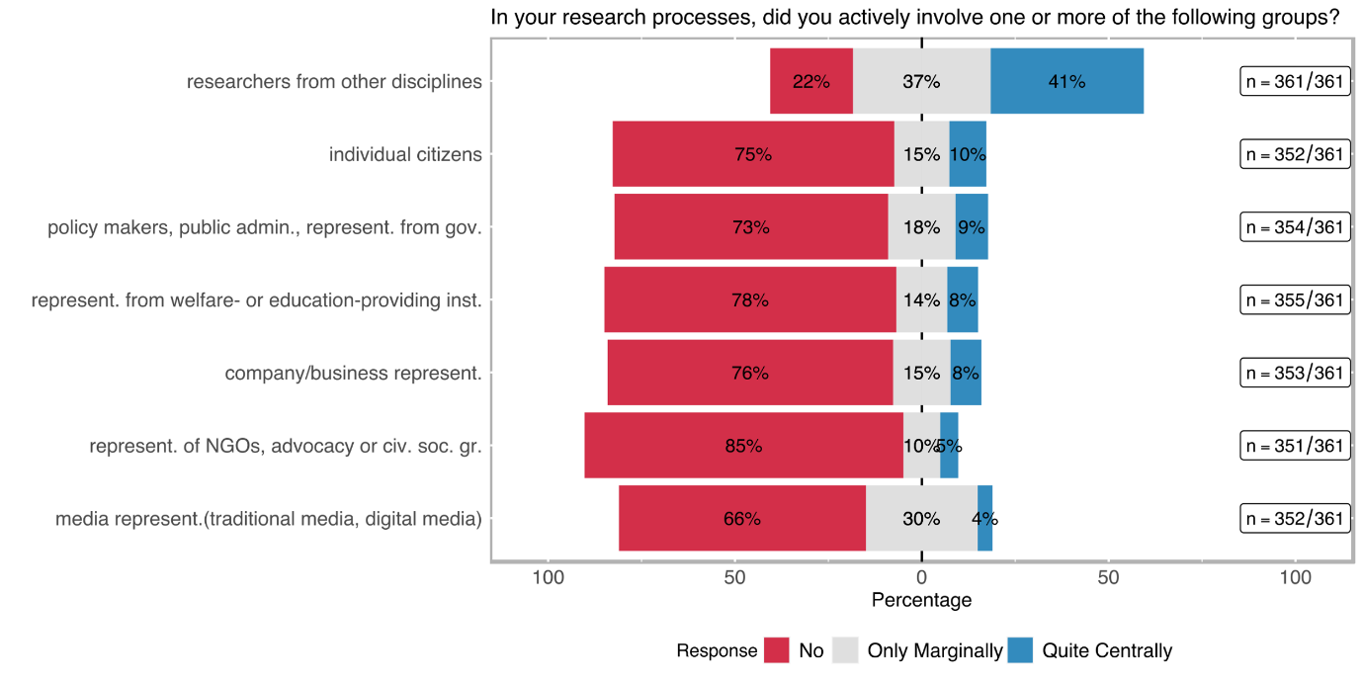

Table 3: Level of interdisciplinary and transdisciplinary involvement

|  |  |  |  |  |  |  |
| --- | --- | --- | --- | --- | --- | --- |
| **Involved stakeholder group** | **no** | | **only marginally** | | **quite centrally** | |
|  | **abs** | **%** | **abs** | **%** | **abs** | **%** |
| **ACADEMIC** |  | | | | | |
| **researchers from other disciplines (n=361)** | 80 | 22.16% | 133 | 36.84% | 148 | 41.00% |
| **NON-ACADEMIC** |  | | | | | |
| **company/business representatives (incl. farmers) (n=352)** | 269 | 76.42% | 54 | 15.34% | 29 | 8.24% |
| **representatives of NGOs, advocacy or other civil society groups (n=354)** | 302 | 85.31% | 35 | 9.89% | 17 | 4.80% |
| **policy makers, public administrations, representatives from governmental agencies (n=355)** | 260 | 73.24% | 64 | 18.03% | 31 | 8.73% |
| **individual citizens (e. g. as beneficiaries, customers, or concerned persons) (n=353)** | 266 | 75.35% | 52 | 14.73% | 35 | 9.92% |
| **media representatives (traditional media, digital media (e. g. bloggers), journalists, community-led media, etc.) (n=351)** | 232 | 66.10% | 105 | 29.91% | 14 | 3.99% |
| **representatives from welfare- or education-providing institutions (such as schools, kindergartens, hospitals, or care centres) (n=352)** | 275 | 78.13% | 48 | 13.64% | 29 | 8.24% |

To complement the above-mentioned inclusion of stakeholder groups in transdisciplinary research, it might also be interesting to see how many projects chose to work with more than one group, during their implementation. As Figure 9 shows, 37 % of projects did not include any stakeholder groups – in contrast to Figure 8, this means that the share of projects that do not involve any stakeholder groups outside academia is roughly only half as high as the share of a particular stakeholder group to be involved. In fact, the share of projects that include at least one and up to three different stakeholder group amounts to 48 %; 9 % of the surveyed projects include even more than 3 (out of 6) different types of stakeholder groups.

Figure 9: Stakeholder groups involved in transdisciplinary research

Although the centrality of the involvement of stakeholders indicates to which extent specific groups were involved in the project, the role which participating social groups play in transdisciplinary research is often overlooked. Motivated by our literature research, we decided that the *nature of involvement* (indicated with the labels; *consultative, contributory, collaboratively, co-created*) carries at least as much information as the centrality of the involvement about the occurrence of SI-related aspects.

Figure 10 and Table 4 show that *transdisciplinary involvement* is mostly *consultative* or *contributory*. *Collaborative transdisciplinary* involvement is more likely employed when welfare/education institutions or company/business experts are involved in the project (20 % and 22 % respectively). A co-creation approach is rare being followed: the highest co-creative involvement belongs to projects that include individual citizens (10 %).

Figure 10: Nature of transdisciplinary involvement per stakeholder group

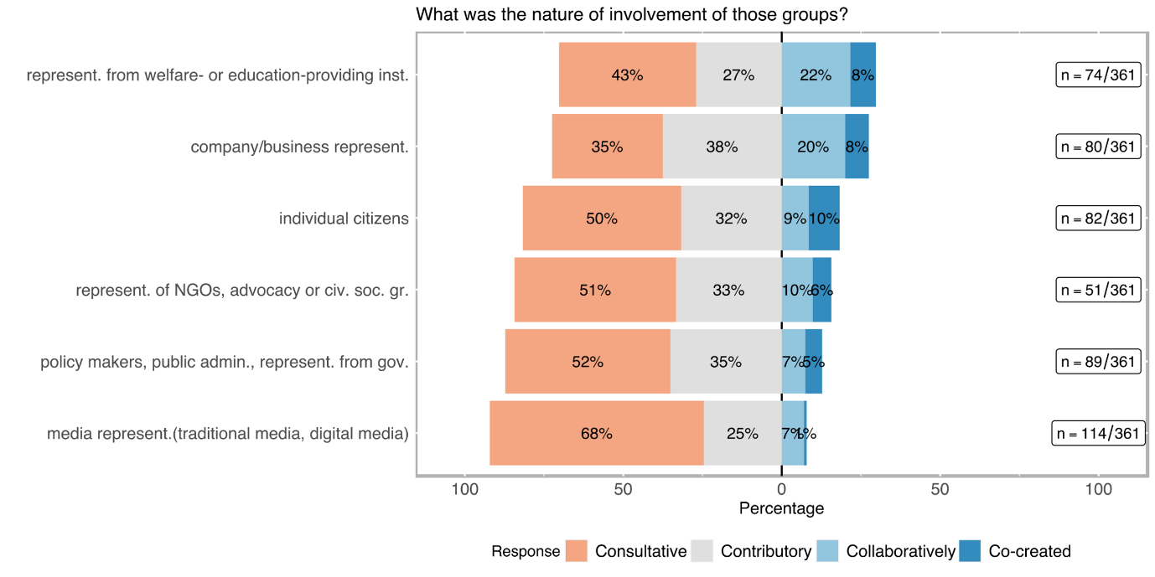

Table 4: Nature of transdisciplinary involvement per stakeholder group

|  |  |  |  |  |  |  |  |  |  |  |
| --- | --- | --- | --- | --- | --- | --- | --- | --- | --- | --- |
| **Involved stakeholder group** | **consultative[4]** | | **contributory[5]** | | | **collaborative[6]** | | | **co-created[7]** | |
|  | **abs** | **%** | **abs** | | **%** | **abs** | **%** | | **abs** | **%** |
| **ACADEMIC** |  | | |  | | | |  | | |
| **researchers from other disciplines (n=278)** | 37 | 13.31 | 57 | | 20.50 | 109 | 39.21 | | 75 | 26.98 |
| **NON-ACADEMIC** |  | | |  | | | |  | | |
| **company/business representatives (incl. farmers) (n=80)** | 28 | 35.00 | 30 | | 37.50 | 16 | 20.00 | | 6 | 7.50 |
| **representatives of NGOs, advocacy or other civil society groups (n=51)** | 26 | 50.98 | 17 | | 33.33 | 5 | 9.80 | | 3 | 5.88 |
| **policy makers, public administrations, representatives from governmental agencies (n=94)** | 49 | 52.13 | 33 | | 35.11 | 7 | 7.45 | | 5 | 5.32 |
| **individual citizens (e. g. as beneficiaries, customers, or concerned persons) (n=82)** | 41 | 50.00 | 26 | | 31.71 | 7 | 8.54 | | 8 | 9.76 |
| **media representatives (traditional media, digital media (e. g. bloggers), journalists, community-led media, etc.) (n=114)** | 77 | 67.54 | 28 | | 24.56 | 8 | 7.02 | | 1 | 0.88 |
| **representatives from welfare- or education-providing institutions (such as schools, kindergartens, hospitals, or care centres) (n=74)** | 32 | 43.24 | 20 | | 27.03 | 16 | 21.62 | | 6 | 8.11 |

4.2.3 Inclusion of stakeholders in the project exploitation phase

Our proposal aims to trace contributions of research funded by SNSF to social innovations, and to systematise these contributions in a valuation framework. In addition, we aim to identify to what extent contributions to social innovation in SNSF-funded research projects are possible at all, and where further support measures, either provided by SNSF or from outside (e.g. by the universities), could create an added value that could not be tapped so far.

Dissemination and Exploitation

Dissemination Channels

Figure 11: Distribution of dissemination channels

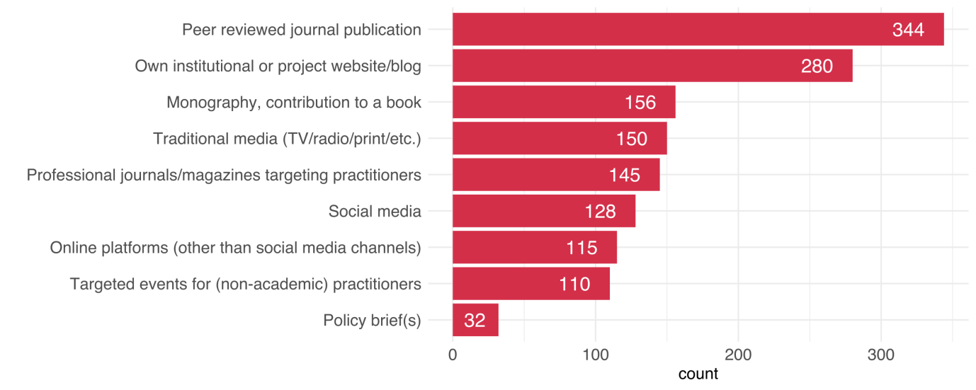

How a project disseminates its results can provide important information about the project’s character and intention. Some of the options like peer-reviewed journal publications or the dissemination on the organisations’ own website have unsurprisingly high numbers (see Figure 11). In general, however, a wide range of dissemination channels was used, including books, traditional and social media, and articles in professional journals for practitioners etc. Policy briefs were rated lowest but 110 projects stated to have organised events for non-academic practitioners (see Table 5).

Table 5: Dissemination channels

|  |  |  |  |  |
| --- | --- | --- | --- | --- |
| **Dissemination channel** | **no** | | **yes** | |
|  | **abs** | **%** | **abs** | **%** |
| **Peer reviewed journal publication (n=358)** | 14 | 3.91% | 344 | 96.09% |
| **Monography, contribution to a book (n=342)** | 186 | 54.39% | 156 | 45.61% |
| **Conference proceeding (n=356)** | 52 | 14.61% | 304 | 85.39% |
| **Policy brief(s) (n=333)** | 301 | 90.39% | 32 | 9.61% |
| **Traditional media (TV/radio/print/etc.) (n=346)** | 196 | 56.65% | 150 | 43.35% |
| **Professional journals/magazines targeting practitioners (n=343)** | 198 | 57.73% | 145 | 42.27% |
| **Own institutional or project website/blog (n=354)** | 74 | 20.90% | 280 | 79.10% |
| **Social media (n=347)** | 219 | 63.11% | 128 | 36.89% |
| **Online platforms (other than social media and project website/blog; e. g. data or code sharing, citizen science platforms) (n=343)** | 228 | 66.47% | 115 | 33.53% |
| **(You providing) consultancy (paid or unpaid) (n=342)** | 226 | 66.08% | 116 | 33.92% |
| **Targeted events for (non-academic) practitioners (n=343)** | 233 | 67.93% | 110 | 32.07% |
| **General events for a non-academic public (other than practitioners) (n=343)** | 207 | 60.35% | 136 | 39.65% |

### Communication and dissemination

Dissemination is a crucial driver of change. Different projects used different dissemination and communication strategies. However, there is no clear pattern of whether certain fields choose specific channels. Rather, the motivational aspects and the intended purpose of the research seem to guide dissemination activities. Accordingly, those interviewees who identified a relevance for practice and transdisciplinary aspects early on in their research projects argue that workshops, training programmes and conferences that are open to non-academics are crucial for fulfilling impact outside of academia.

One aspect that was brought up by almost all interviewees, who undertook dissemination activities, was the aspect of science communication to the public. Accordingly, it is seen as important that research findings are not only communicated to specific stakeholders (e.g., practitioners) but also to wider society. Depending on the field and discipline, different project teams initiated different strategies to bring results to the public. For example, one interviewee gave talks in museums, while others talked to the media.

Another crucial aspect that was pinpointed by many PIs is that dissemination and science communication can not only contribute to social innovation by producing outcomes but by sharing these outcomes.

*“Well, we have always tried very hard to convey and make our information available in a form that / both in terms of the way it is presented, but also in terms of accessibility. For example, we have [results] publicly accessible and we also have, you can see that, we have a website where we also show it, where we actually make everything accessible, with just a few exceptions, that's an important thing for us. It is also a prerequisite that something like a transfer takes place and that ultimately other actors do something like social innovation with it.” Interviewee 19*

Generally, interviewees mentioned ten different dissemination channels. Some only used one, while others combined different sources:

1. **Publication in academic outlets:** Almost all interviewees said that they published their results in academic journals or as a book targeted at the scientific community. Again, the pressure to publish was stressed by many interview partners. Accordingly, academia requires researchers to actively publish, often in a way that is referred to as “quick and dirty”, which takes time away from other dissemination activities.
2. **Publication in non-academic outlets:** Besides publishing articles in academic journals, some interviewees also chose to publish their results in non-academic outlets. One interviewee, for example, said that he published his project findings in specific magazines for practitioners. Another highlighted university magazines which required the team to think about the issue of how to make the topic interesting and accessible for students.
3. **Policy reports:** A few interviewees said that they wrote policy reports, some of which were commissioned by a political authority while others were not. One interviewee, however, stressed that a policy report could only be effective when then discussed with the responsible people. Therefore, writing such a report without a dialogue afterwards can prove less promising when trying to engage with decision-makers.
4. **Open-access material:** Four interviewees mentioned that they published their data sets with the aim to help other researchers to improve their work. Accordingly, open-access databases can be important for further analyses, and on the other hand, they can also serve as a communication tool. One interviewee, for example, stressed that he not only makes his data freely available but uploads all project outputs (reports, articles etc.) on a website in order to make all findings publicly accessible.
5. **Lectures and teaching:** Lectures and teaching were also seen as an essential channel for the communication of project outcomes. While most researchers who used lectures as a source for dissemination did so in a university context, some highlighted the importance of further training of practitioners. Accordingly, one interviewee stressed that in his case, it was essential to directly feed the results into practitioners’ training, wherefore he engaged in teaching activities targeted at experts rather than students. Another interviewee claimed that in order to reach people not only in Switzerland but also abroad, a Massive Open Online Course can help overcome distance in dissemination.
6. **Interviews and discussions:** Five interviewees mentioned that they gave interviews, either for magazines or during discussion rounds. Others noted that they took part in round tables which were mostly aimed at the public. Those interviewees who participated in such activities highlighted that this gave them the chance to put their research more into context. Respectively, one interviewee expressed that conferences are very useful for dissemination. However, they are often very focused on topical details. Round tables and discussions, which are open to the public, are more characterised by openness and less scientific language.
7. **Conferences and presentations:** Two of the most used dissemination channels were conferences and presentations. Although conferences were mostly targeted at an academic audience, some interviewees mentioned that they presented their findings at conferences either to the public or practitioners. Similarly, others highlight that they were invited to give presentations at other meetings. A lot of interview partners underline the informal parts of such events. Correspondingly, getting to know people and having dinner together can be an important step for widening one’s network and act as a stepping stone for future collaborations.
8. **Media:** One-fourth of the interviewees said that they talked to the media as a dissemination strategy. Some of them stressed that journalists were very interested in their research and that they gut numerous requests for interviews. Contrarily, others claimed that it was quite hard to raise journalists’ interest, which according to the interviewees, was because their research phenomenon was less of a “hot topic”. Nonetheless, all of them noted that the media can be an important source for dissemination as it is able to reach an audience that researchers mostly have problems reaching.
9. **Website:** Sometimes, research projects were represented and summarised on specific websites. Those interviewees who mentioned open-access databases also referred to their projects’ websites as they provide the downloads there. However, there were a few cases where interviewees mentioned their website without having open-access material.
10. **Excursion:** Two interviewees reported that they went on excursions where they visited practice partners and experts from other countries. This enabled them to put their findings into perspective and get feedback from people who work in different contexts. According to one interviewee, this allowed the research team not only to take about their findings but also to acquire deeper knowledge about the structures and practices outside their research field.

4.3 Productive interactions: Obstacles and attempted solutions

Challenges of transdisciplinarity

1. **Systematic and regulative challenges:** In some cases, interviewees experienced systematic barriers when interacting with non-academic stakeholders. This was especially reported by researchers who mainly worked abroad. Additionally, some research institutions (e.g., Pädagogische Hochschule, Art Universities) are not allowed to award their own PhDs and find it difficult to act in the SNF project framework, in addition to being dependent on other institutions to have PhD students.
2. **Certain Stakeholders are hard to reach:**

* When they belong to institutions like official authorities, administration, or other actors within the political and legal system, they are interested in controlling their own narrative and are focused on functioning or self-presenting and have little interest in being questioned.
* Institutions like hospitals or schools: everyone is very busy, tight schedules, in which research projects from outsiders are not the main priority; also, managing a hospital (or other state-funded welfare providing institutions) has a lot to do with politics. In complex institutions like schools and hospitals, multiple stakeholders with multiple interests are involved, which means that they will try to implement their own interests and prevent the interests of others from diametral to their own.
* When they belong to a marginalised group or groups in precarious situations, it’s difficult to access and approach these stakeholders – they often have little motivation to talk about their situation to outsiders, they are too busy taking care of their own problems and cannot deal with the researchers’ problems.

*“Of course, not all groups of people can be approached with the same ease, and there is of course what we find is, that above all, the people who are actually most affected, namely those in economically and socially precarious situations […]” Interviewee 5*

*“On the other hand, it is […] difficult to approach the really precarious people, people in precarious situations, excuse me, because of course they often see themselves pushed on the defensive by their precarious situation to such an extent that they don't feel like it at all, having to talk about it.” Interviewee 3*

* Interest groups and associations (e.g., patient associations): They can be suspicious of the research projects or question the researchers’ intentions.

1. **Challenges in communication:** Communication between academic and non-academic stakeholders can be challenging due to different knowledge, different practices or norms, different priorities or perspectives regarding the same topic or because they speak different languages.

*“The point is to make it possible to communicate to someone exactly what was actually relevant in the project, that is, this transferability of what one has actually experienced and worked out philosophically or politically, philosophically or literary-theoretically, whatever one may call it.” Interviewee 9*

1. **Different knowledge:**

* **About scientific or methodological concepts:** For instance, one researcher described issues in presenting statistical results, which are generalised to the sample, but where single practice partners involved in data collection do not feel represented and feel like their own experience is not reflected in those statistical results. At the same time, other practice partners did have experience in statistics, and thus, presentations should not be too simple for them.
* **About the prevalence of issues or disorders:** One researcher involved in medical research reported that the medical practitioners underestimated the relevance of the research topic and wouldn’t understand or listen when they were told about it as they were focusing and trained in a different aspect of the issue.
* **About how scientific investigations can be relevant in practice and everyday life:** As one researcher elaborated, it is also part of the researcher’s job to establish connections and relevance for non-academic audiences. Accordingly, it is essential to make abstract concepts accessible and concrete. However, it is often difficult to communicate this relevance.

1. **Different practices** in decision-making, which hampers productive interactions and prompts researchers to communicate with different stakeholders (find a work around by talking to an NGO instead of the administration) to reach their goal. In particular, in political and legal research, practices and norms are highly dependent on political interests and political majorities, which can also fluctuate over the course of one research project.
2. **Different theories and representations of phenomena:** Practice partners develop their own explanations of the issues they encounter every day (e.g., why a child acts out) and can have different representations of certain issues and concepts than researchers have. The confrontation of these differences can result in conflict, and connecting them is difficult.

*“And I think such differences in perspective and also differences in, so to speak, theorizing of the whole, simply has its potential for conflict.” Interviewee 20*

1. **Different practices in using results:** While researchers are encouraged (by SNF, their university, and the whole of the scientific community) to publish a lot and to publish open access, this is disadvantageous for industry partners, who need to protect a result and keep it to themselves in order to profit from it.
2. Investigating research participants’ practices can feel like the researcher is criticising these practices, which can result in conflict. This is particularly difficult as researchers often depend on existing practice contacts to gain access to new research fields and institutions and thus feel like they cannot allow themselves to offend their practice partners. This balance between doing rigorous and independent research and keeping contacts for further studies is experienced as challenging by some.

*“There's this feeling of someone stepping on their toes, pointing out what was wrong.” Interviewee 4*

1. **Different priorities, interests and perspectives:** When interacting with non-academic practice partners and contacts, researchers are confronted with many different expectations of what their research should achieve. The scientific aspect of producing and disseminating knowledge can easily collide with the interests of practitioners, the industry, or the media, which sometimes are detrimental to the rigorous scientific process.

* **Producing knowledge vs. solving practical problems:** Researchers and practice partners often have different interests. Researchers want to focus on research, while practice partners want to solve their problems. Research takes a long time, is meticulous, and it’s unclear whether it will actually result in anything useful as the primary purpose of research is to produce knowledge. Practice partners often have the expectation that research can solve their current problems and provide concrete solutions. This can result in a mismatch of expectations. In addition, the problems researchers identify in their projects might differ from what practitioners experience as problems, leading to their rejection of the results. Convincing practitioners of scientific results that are not in line with their everyday experience is a challenge.

*“[…] the expectation, an excessive expectation of research, that it can solve problems that research doesn't actually solve at all, because it primarily produces knowledge.” Interviewee 9*

* **Producing knowledge vs. making profit:** Similarly, researchers and practice partners from the industry differ in their interests in that industry partners focus on getting a product ready for market entry, easily implementing or building a product, and making a profit. They are more focused on certain usable parts of the project and not necessarily on the research process. Additionally, they might conclude different things and have different ideas of how to utilise the results.

*“I think the main challenges for me was that we, me and my researcher, we were always thinking at the modelling level - let us say, how could these things better capture what we wanted to capture, while at the company level, if I remember, the interest was much more - how easily can we implement this, how fast they can go.” Interviewee 19*

* **Producing new knowledge vs. sticking to own practice:** The phenomena investigated in the research projects are complex and multi-faceted. Some of the researchers encountered challenges in the communication with transdisciplinary partners when they were not interested in experiencing new facets of the phenomenon at study but rather stuck to their area of expertise or were discussing the phenomenon from a perspective irrelevant to the researcher. Some of the researchers experienced a certain unwillingness of those partners in engaging in a discussion about new insights into the topic. This certain reluctance for new insights might result from the effort it takes to include these new insights into practice: it might require changing protocols and routines, but it might also take more time and investing already scarce resources.

*“So, clinicians can be very reluctant to get into research issues, because they don't think that's their goal. They don't want to add preparatory time, they don't want to complicate clinical protocols.” Interviewee 7*

* **Being accurate vs. catchy headlines:** Some of the researchers were in contact with media representatives, e.g. journalists, who interviewed them. They described that they aimed to present their research accurately and objectively, whereas journalists were more interested in generating a catchy headline to spike interest. Particularly in research with vulnerable groups, researchers were concerned that these would be exploited or put at risk in exchange for the headline.

*“It is clear to me that the newspapers have a certain way of reporting the news that is not necessarily convertible for us or should be.” Interviewee 10*

*“The media are of course looking for the catch, i.e. the headline they can make of it, that was / sometimes you have to swallow a bit and accept that they are looking for headlines, but that’s okay.” Interviewee 6*

* **Conflicting relationships with stakeholders:** It is important to realise that there can be various different stakeholders associated with a research project, which can also have conflicting relationships with each other, with diverging interests, or are embedded in a hierarchy defined by different priorities and perspectives. Negotiating these relationships and deciding on which interests to focus can be a challenge for researchers.

*“You always will have different groups of people and probably this raises the problem of who are the stakeholders, so, when in social innovations teams they say, "oh make it usable for stakeholders", okay, but who are the stakeholders, are there conflicts within the stakeholders, are hierarchical effects in the sense that, for example very clearly in the kind of work that I do.” Interviewee 2*

* **Negotiating:** If practice partners are more strongly involved in the planning implementation of the research project, challenges can arise when negotiating the term of joint contracts or agreements as there are different understandings of the phases in the project and research cycle or what to conclude from research results.

1. **Different language – different terms, concepts, horizons of understanding:** Some researchers express challenges regarding language which hampers understanding, both in the sense of country-related language issues and discipline/field-related issues. This includes specific acronyms, names, and terms that are used in certain disciplines or sectors.

* Especially when dealing with highly formalised institutions such as political, legal or administrative actors, who have their own formal “language”, conflicts and frustrations can arise when the communication does not work, which can also lead to partners withdrawing.

*“And then also to understand the whole language of the administration, so to speak, and the whole language of the political structure in general, we have seen that, with all the good will that is present, there are also a lot of areas of friction, it there are a lot of misunderstandings, there are a lot of people who get out of this process relatively quickly in frustration.” Interviewee 8*

* In some practice contexts, partners might have difficulty in understanding scientific terms and concepts or even show reluctance towards “scientific language”, as they feel it is too abstract and too distant from their everyday work.

*“Perhaps the scientific language is not understood, or no attempt is made to understand it, that there is a certain defensive attitude towards research, the findings from science, that is complicated and has little to do with my practice.” Interviewee 11*

* Language difficulties not only arise when communicating with practice partners but also with researchers from other disciplines. It can be a challenge to find a common language and jointly identify common goals and strategies. Collaboration between disciplines thus requires that researchers listen to each other, teach each other, and learn together. These challenges are increasingly relevant considering that funding schemes require or foster interdisciplinary project teams. This is experienced as very difficult for some researchers.
* Researchers also need to adapt their language and communication towards practice partners, as pointed out by one researcher. It is not helpful if researchers tell practice partners what to do, as they know very well which problems they experience. Rather, communication should be approached as joint development of ideas and solutions. At the same time, presentations of research results should be adapted to the level of knowledge and usual language of the audience. “[…] who are really far away from an academic education, and you want to somehow sensitise them to the topic, but at the same time present serious research - and that is sometimes not so easy.” (Interviewee 3)
* Some researchers experience language barriers when dealing with international practice partners or stakeholders. These barriers can result in missing some subtleties when conducting interviews in qualitative research but also when interacting and networking with other researchers and stakeholders. This makes communicating accurately and exhaustively difficult and excludes stakeholders and potential beneficiaries from benefiting from research.

1. **Resistance and opposition:** Some researchers experienced resistance and opposition to their project from practice contacts and in discussions with these non-academic contacts, found that they were offended by the research activities (e.g. questioning a concept, evaluating the success or failure of activities). This resistance consisted of people feeling attacked, people avoiding interactions or questioning the meaningfulness of the project.

Skills for transdisciplinary research

Interviewees identified skills that can enhance the cooperation and exchange with non-academic stakeholders.

1. **Value-free communication:** Several interviewees stressed that value-free communication can facilitate the exchange with stakeholders, especially when dealing with controversial topics. According to one interviewee, this is particularly crucial when talking to the media since statements might be used out of context to strengthen the media's narrative around a certain topic. Another interviewee stressed that while it is common in her field to have a normative perspective on the topic, she tried to stay as objective as possible in order not to bias the research. Further, it was stressed that value-free communication is also helpful to break down barriers between two opposing sides who might have remarkably different opinions on the research phenomena.

*“If you (…) have an interest in seeing it through, then you know, it is part of developing relationships, right, with these individuals, and multiple meetings and engagements, and so after a while you start to learn their language and, you know, how they are approaching a problem, and they start to learn yours, and what you can do or cannot do. And then you start to appreciate when they are uncomfortable, because they do not quite understand what you are saying. And they appreciate when you are uncomfortable, because you do not understand quite what is involved, right. So, it may be uncomfortable, but it is part of the fun of breaking out of your box, and in this case, with the purpose of engaging in a project that would have greater societal innovation" Interviewee 12*

1. **Concreteness:** Similar to value-free communication, interviewees mentioned concreteness as a useful skill for interactions with actors outside academia. Accordingly, a message should be clear and easily understandable such that no room for misinterpretation is left. Otherwise, such misinterpretations could create problems for both parties, i.e. conflicts. One interviewee, for example, claimed that in order to talk to decision-makers or businesses, he tries to avoid “irrelevant information” and always uses facts and figures to underline his main points. Another interviewee stressed that vagueness causes uncertainty which leads to inefficient communication. This can, inter alia, be avoided by using examples.
2. **Making topic accessible:** Another related aspect is the skill to make the research topic as accessible as possible. Respectively, several researchers stressed that different stakeholder groups have different knowledge of and interests in the research issue. Hence, in order to ensure the participation of and effective communication with stakeholders, the topic should be apprehensible for as many stakeholders as possible. To achieve this, it was highlighted that different ways of communication tailored to a certain target audience are useful to make the discourse around a project as inclusive as possible.
3. **Experience outside university, practice experience:** Additionally, a few interviewees stressed that their experience of working with non-academics had helped them to acquire skills needed for transdisciplinary research. Two interviewees, who also work at non-academic institutions, underlined that this allows them to acquire knowledge from inside the field as well as constant feedback from practice partners. Others highlighted that the success of transdisciplinary exchange strongly depends on how experienced you are with communicating with non-academic stakeholders.
4. **Stay in discussion:** In order to facilitate contact with stakeholders, many interviewees emphasized the need to create long-term contacts. Although this is not possible for some stakeholder groups (e.g., society at large), staying in touch with professionals, institutions or civil actors can help build up trust in the field and maintain and deepen relationships. One interviewee summarized this the following way:

*“So, it is an evolutive thing, but I understand that as a continuous, in time, a continuous trust relationships, relationship, where people from one session to the other, one meeting to the other, one gathering to the other, they get to know you better, and I talk abundantly about what I am doing and in a way that evolves also in time, it is very informal, but I think it is central for the circulation of ideas.” Interviewee 2*

Hence, preserving a network of relevant stakeholders can be beneficial in many ways. First, it eventually leads to more in-depth interactions as people get to know each other and build up trust. Second, the cultivation of productive relationships further stimulated the development of projects and future project ideas.

1. **Create knowledge transfer:** One central aspect that was highlighted by many interviewees is the creation of knowledge transfer. This has several facets. Firstly, some interviewees claimed that including students (through teaching but also in projects) is an essential way to transfer knowledge. Others stressed dissemination at conferences and events fosters knowledge transfer between different universities but also different stakeholder groups. Some interviewees stressed that support regarding the transfer of knowledge would be helpful, i.e. coordinating activities to promote either internal exchange, inter-departmental exchange or transdisciplinary endeavours. One interviewee mentioned the concept of “open innovation” which fosters the circulation of knowledge instead of a “one-sided, one-way transfer”, where universities can play a key role.
2. **Personal commitment from partners:** Further, a few interview partners expressed the necessity of personal commitment from all sides. According to one interviewee, research is time and energy consuming, which is why efficient cooperation can reduce the workload for everyone. However, such cooperation can be very tiring and actually increase the time and energy needed to finish projects when partners do not fully commit to the sense. Another interviewee criticized funding schemes where researchers are “forced” to collaborate because an international consortium is required. Accordingly, while this collaboration can work out very well, it can also go very wrong when people do not know each other and are “pick’n’mixed”.
3. **Mediating role/broker:** Lastly, taking a mediating role can benefit transdisciplinary research. Correspondingly, one interviewee who worked with stakeholders that had significantly opposing interests stressed the importance of “sharing information, objectifying of the debate and putting the arguments back on the table in a disciplined discourse”. Accordingly, researchers who bring together diverse stakeholders also need to be skilled in negotiating interests and de-escalating conflicts. Another interviewee claimed that in order to bring the practice and the academic side together, researchers have to take on a mediating function:

*“And I think that from the point of view of communication, of course you have to, you have to try to shape communication in such a way that it is understood by the practice contexts. And that needs both sides. So for me, creating relevance to practice is actually the task of science and practice together. And that presupposes that one has an understanding of both worlds. So we often talk about a double competence profile that we want to bring along or develop.” Interviewee 13*

1. **Knowledge brokers:** Some researchers who experienced challenges in communication tried to communicate through or with the help of third parties, which can be seen as knowledge brokers. This can be NGOs, project partners who also have experience in applied fields or well-meaning contacts from the practice field who are in support of the research project. It needs to be someone who is familiar with the routines and practices of the respective institution, is familiar with the people that work there and are in charge, and can convey the project’s relevance, thereby also implementing the first transfer of knowledge. However, knowledge brokers need to be similarly acquainted with communicating with researchers (not only with practice partners), meaning they need to understand the issue at hand, be familiar with research processes and methodology, and with academic discussions. Thus, a knowledge broker represents a bridge that is firmly anchored on both sides – both research and practice. This is especially the case,
   * when dealing with topics regarding more vulnerable or excluded groups, knowledge brokers also act as a voice representing them if it is difficult for them to speak for themselves, for example, in the form of interest associations and NGOs.
   * in institutionalised settings like politics or administration, where tacit knowledge is required for efficient communication and knowledge transfer.

*“The first thing I have to do is, I have to, within each of these ministries or organisations, identify an “insight champion”, someone who works in this ministry, who is convinced of the project and can convince his peers why this is a useful thing to try for the ministry. Because, these people are embedded in the organisation, speak the language of the organisation, and so are much more effective than I will ever be in making a case for trying that.” Interviewee 9*

1. NEW SOCIAL PRACTICES? OUTCOMES AND LIMITATIONS

5.1 Motivation and intended social innovation outcomes

Our proposal aims to trace contributions of research funded by SNSF to social innovations, and to systematise these contributions in a valuation framework. In addition, we aim to identify to what extent contributions to social innovation in SNSF-funded research projects are possible at all, and where further support measures, either provided by SNSF or from outside (e.g. by the universities), could create an added value that could not be tapped so far.

Novelty and Innovation

We identified several indicators regarding the novelty and innovation of research projects within the scope of the interviews. These can be summarized in two broad categories: 1. relevance for practice and transdisciplinarity and 2. scientific innovation and new approaches in science. The former relates to the contribution of projects to actors outside of academia and the involvement of non-academic stakeholders. The latter refers, on the one hand, to new scientific results and outcomes and, on the other hand, to novel approaches in science in general or in specific academic fields.

**Relevance for practice and transdisciplinarity**

Projects differed vastly in both their degree regarding novelty but also which innovative aspects they offered. Almost half of the interviewees reported that the novel aspect of their research was the contribution to practice, for example, the improvement of teachers’ training and medical treatment. Other interviewees argued that their innovative aspects lie within the inter- and transdisciplinary aspects of their research design. Consequently, while many of those who identified relevance for practice, not all of them confirmed inter- or transdisciplinary elements in their research. This means that while practice-oriented research is essential, it does not necessarily lead to interdisciplinarity or transdisciplinarity. On the other hand, all of the interviewees who conducted transdisciplinary research argued that their research projects were also tied to the relevance of researched phenomena in the practical world.

Moreover, interview partners argued that there is a “feedback loop” between academia and practice, which offers a ground for learning. One interviewee recounted that while practitioners can learn from academic knowledge, researchers can benefit from incorporating “practical knowledge” into their projects.

*“First of all, we describe what the professionals do because, in the institutions, we often don't know what the professionals do. There is a diversity of practices, so it is really important to go to the institutions, to go to the field, to describe what professionals do. And there is a knowledge that is built up among social workers - so this is something that is attributed to all professionals, but in social work, as it is highly experimental, it is even stronger. There is something of an invention in the work. So, it's very important to be able to produce knowledge for that. Already for professional training, there is something of social innovation, because the idea is to allow the training of social workers to be nourished by the new knowledge that is built up in the field. Because obviously, in the institutions, in addition, the problems evolve. They evolve all the time. There is this basic innovative side.” Interviewee 1*

Furthermore, some interviewees mentioned that although their research is generally more theoretical and foundational, they understand their scientific activity always as related to practice. Although some interview partners claim that the boundaries and limits of foundational research are the limited impact it can have outside of academia, others highlight that these boundaries can be overcome. This, for example, can be achieved by incorporating translational science aspects into the project from the start but also at later stages, e.g., by flexibly including stakeholders, pursuing dissemination strategies or undertaking exploitation activities.

Hence, it is emphasized that relevance for practice and potential impact is seldomly related to the scientific field or foundational research.

Besides the relevance for practice, some interviewees noted that the innovative aspects of their research are connected to the motivation of raising awareness amongst wider society and citizens.

**Scientific innovation and new approaches in science**

Another aspect of novelty is related to scientific discoveries, academic innovations and new ways in and of doing science. Several interviewees reported that the novel part of their research was the way they approached the project. This, for example, could be concepts or techniques that are either new to academic science in general or to their respective fields. Some interview partners referred to the unique approach the research team employed within the project. Accordingly, in many fields, it is not common to choose a flexible and open research design because of many reasons; two being academic standards and funding criteria. Yet, some respondents argued that such an approach, i.e., letting questions emerge from the research design, enabled the researchers to gain valuable insights and contributions to more solution-oriented work.

Others highlighted that by simply introducing aspects from other disciplines into their research, the potential impact of the results and findings for academics and practitioners alike multiplied. For example, one interviewee mentioned that the research team decided to include more than what is considered “enough” participants in the projects, which is very common in other fields (e.g., sociology) but not in psychology. Other interviewees mentioned very similar approaches differing in details but having one aspect in common: All of them stressed that such very “minor” adjustments in research designs could drastically affect the outcomes of projects. This can, in turn, positively impact academia as academic practices are advanced while also benefitting the non-academic world.

Similarly, it is emphasized that while interdisciplinarity is quite common in some research fields, it is not quite utilized in others. Yet, some researchers decided to incorporate interdisciplinary aspects, albeit uncommon in their field, into their project since they believed that such an approach could contribute to a more holistic perspective on the researched topics. This could, for example, be the interaction between more fundamental and applied research but also between natural and social science. Hence, it becomes clear that scientific innovation does not necessarily have to be a scientific breakthrough. Instead, overcoming disciplinary boundaries and designing research projects not only according to the standards of one field but two or more can be very innovative and eventually lead to impact both in and outside of academia.

. Our analysis approached to the research motivation and agency from different directions by identifying types of motivation and intention to benefit the society outside of academia.

Motivation types

The type of motivation that drives academics to conduct research is important to understand the content orientation, the design, and the results of the study. The initial motivation types measured in this study consist of three main categories, namely, motivation to *better understand a natural, technical, economic, or social phenomenon* (basic academic motivation that drives research), to *directly address a natural, technical, economic, or social problem* (use-inspired research)*,* to *improve the human condition/welfare* (motivation to create impact outside of academia).

The basic academic motivation to better understand a natural, technical, economic or social phenomenon was strongly emphasised in the survey results (see Figure 12): 84 % of the survey respondents marked academic motivation greater or equal to 7 on a 0-10 scale, it has also one of the highest response ratios in the survey (only one responded did not reply to this question). This was followed by motivation to directly address a problem (64 % of the respondents noting equal to or higher levels than 7). Improving the human condition/welfare, i. e. the motivation closest associated with social innovation, namely to cause social impact outside of academia, was more balanced in comparison. 35 % of the respondents replied with levels equal to or smaller than 3 and 45 % with levels equal to or higher than 7, in terms of improving the human condition/welfare being one of the main motivations in their research project. For more detailed responses, refer to Table 6.

We can conclude that the motivation portfolio of SNSF-funded principal investigators is, overall, not one-dimensionally oriented towards only the basic scientific motivation of better understanding a phenomenon, but includes also a remarkable share of problem-orientation and use-inspiration including a quite strongly expressed notion of doing good for human condition/welfare. A high proportion of SNSF-funded projects have thus the motivational potential to more directly contribute to SI through their research.

Figure 12: Distribution of different motivation types

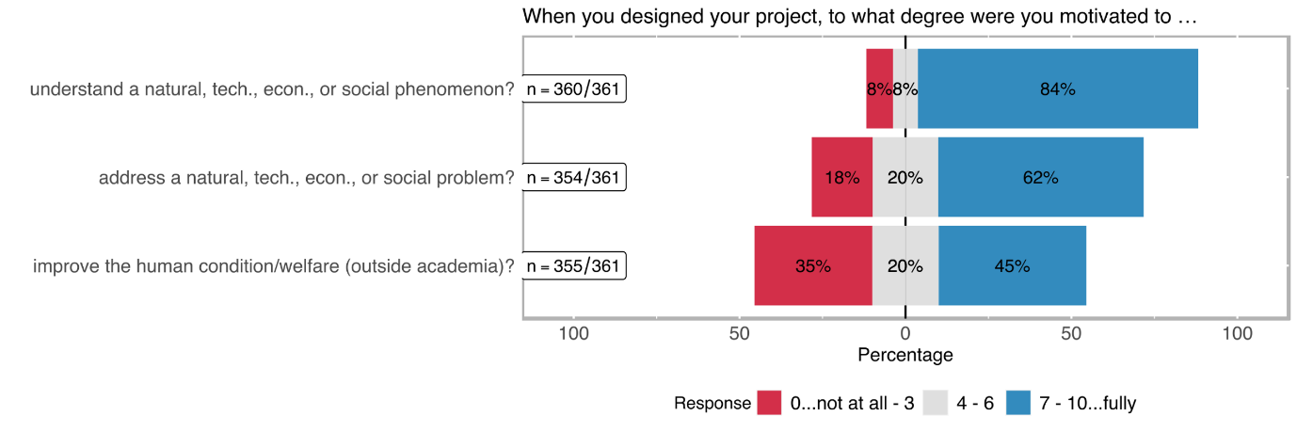

Table 6: Distribution of different motivation types

|  |  |  |  |  |  |  |
| --- | --- | --- | --- | --- | --- | --- |
| **rating** | **better understand a natural, technical, economic, or social phenomenon?**  (n=360) | | **directly address a natural, technical, economic, or social problem?**  (n=354) | | **improve the human condition/welfare (outside academia)?**  (n=355) | |
| *0..lowest*  *10..highest* | **abs** | **%** | **abs** | **%** | **abs** | **%** |
| 0 | 14 | 3.89% | 23 | 6.50% | 47 | 13.24% |
| 1 | 1 | 0.28% | 7 | 1.98% | 23 | 6.48% |
| 2 | 8 | 2.22% | 25 | 7.06% | 30 | 8.45% |
| 3 | 6 | 1.67% | 10 | 2.82% | 26 | 7.32% |
| 4 | 12 | 3.33% | 16 | 4.52% | 16 | 4.51% |
| 5 | 9 | 2.50% | 28 | 7.91% | 43 | 12.11% |
| 6 | 6 | 1.67% | 26 | 7.34% | 12 | 3.38% |
| 7 | 17 | 4.72% | 36 | 10.17% | 41 | 11.55% |
| 8 | 42 | 11.67% | 56 | 15.82% | 53 | 14.93% |
| 9 | 38 | 10.56% | 28 | 7.91% | 15 | 4.23% |
| 10 | 207 | 57.50% | 99 | 27.97% | 49 | 13.80% |
| *no response* | *1* |  | *7* |  | *6* |  |

One of the key factors of social innovation is its social purpose. We were hence interested in whether interviewees identified a social purpose in their research and whether this purpose was already there at the beginning or whether it emerged during the project. More than half of all interviewees identified a clear social purpose; of these, around 40 per cent had a social science background. Consequently, although a research project is not explicitly a social science project, this does not necessarily mean it cannot achieve a social purpose or be socially innovative. For most interviewees (~90 per cent), the social purpose did not change during their projects. For the remaining ten per cent, however, the social purpose intensified during the project implementation. One interviewee, for example, reported that the research team designed the project without having a precise social goal in mind. This then changed as more exchanges with stakeholders took place, and dissemination activities started. Hence, communication and interaction can help change perspectives and put research in a social context.

We were further interested in how researchers served the social purpose they determined in their projects. For this, we divided the means of achievement into three categories:

1. **Prevention:** Some PIs noted that the main instrument for achieving the social aim of their project was to prevent certain situations or circumstances. In many cases, this was the prevention of an illness or psychological disorder.
2. **Better understanding:** This category was by far the most prominent instrument for achieving a social purpose. Many interviewees highlighted that much was unknown in their research field, which made it necessary to delve deeper into details in order to better understand the research phenomena. It further became apparent that most often, inter- or transdisciplinary research design has the goal to conceive phenomena differently; i.e., by bringing different actors or disciplines together, research problems can be explored utilizing the advantages of different angles. Further, a few interview partners stressed that while their main goal was to better understand a research phenomenon, this is indirectly linked to the adjustment and improvement of practices. For instance, it was argued that providing new information for practitioners or the policy level presents the basis for action and decision-making. On the other hand, one interviewee even stressed that the aim of fundamental research is to better understand a problem, which potentially limits the opportunities for impact.

*“But our goal was first and foremost a scientific one in the sense that we wanted to develop a better understanding and explanations and not necessarily to change the world - that was not necessarily our primary goal.” Interviewee 3*

1. **Improvement of, e.g. medical treatment, education, gender disparities:** Another means to achieve a social purpose is to work on the improvement of the issue that is researched. In many cases, this goes one step further than the aim to better understand a phenomenon, as it anticipates actions that need to be taken in order to achieve such an improvement. More than half of all interviewed people said their main goal was to improve a topic of interest. These topics, however, are very diverse and range from the improvement of a product to the improvement of medical treatment and gender disparities. Many interviewees who reported that their goal was to improve something in or outside their field also said that it is essential to first better understand the researched topic. Yet, one interviewee stressed that while more detailed knowledge about a phenomenon is crucial, the motivation to improve the current situation is crucial for change or impact.

What became apparent is that many interviewees, irrespective of their research field, had not only a social purpose but also other intentions in mind. Accordingly, some interview partners highlight that it was crucial for their project not only to consider the social aspects of the research topic but also others, such as economic, ethical or legal elements. Often these aspects seem intertwined and are essential to be acknowledged when aiming for societal impact.

*“We knew, when we studied these particular files, that there were social elements. But we couldn't dissociate these social elements from the financial, technical and technological elements, which were completely integrated into these discussions.” Interviewee 7*

In other cases, interviewees highlighted that there was no immediate social benefit or the direct social aspect was not immediately recognisable. Several interview partners then stressed that there might be a social benefit, but a rather indirect one or one that develops over a longer period of time.

One interviewee reported that the research team realized after the project ended that the social potential of the research had not been exhausted, which then led to follow-up projects with a more specific and clearer social purpose. Furthermore, there were also cases where no social purpose was identified.

Intention to benefit the non-academic world

Approximately 37 % of the respondents note that their projects were not specifically designed to benefit a social group (cf. Figure 13 and Table 7). Almost exactly the same number of respondents indicated that this type of deliberative design was only present to a minor extent in their research project. 25 % of the respondents noted that their projects were specifically designed to generate a benefit for the general population or a specific social group.

Figure 13: Distribution of extent to benefit target groups outside the academic world

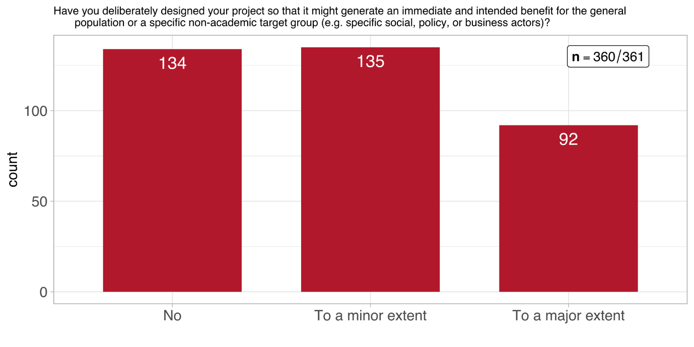

Table 7: Distribution of extent to benefit target groups outside the academic world (n = 360)

|  |  |  |
| --- | --- | --- |
| **response** | **abs** | **%** |
| **no** | 133 | 36.94% |
| **to a minor extent** | 135 | 37.50% |
| **to a large extent** | 92 | 25.56% |
| ***no response*** | *1* |  |

Figure 14 breaks these numbers down by scientific domain. It shows clearly that *Mathematics, Natural- and Engineering Sciences* has the highest number of projects which do not intent to benefit any target groups outside academia. That said, their number if matched by projects in this domain what intent to achieve such a benefit to either a minor or large extent. Out of the three scientific domains, *Humanities and Social Sciences* can – unsurprisingly – claim the highest number of projects which intend to contribute to a large extent to target groups outside academia.

Figure 14: Distribution of extent to benefit target groups outside the academic world across scientific domains

Table 8 shows these values broken down by *funding instrument*. Apparently, none of the them sticks out in terms a considerably higher share of a response category, compared to the overall distribution across categories. The exception seems to be *interdisciplinary projects* but their numbers in the respective response categories are too low to be considered solid evidence. In fact, this kind of distribution is largely reflective of the distribution of all further questions. Therefore, we refrain from repeatedly presenting tables or figures which offer little information value.

Table 8: Distribution of impulses from the non-academic world (n = 360)

|  |  |  |  |  |  |  |
| --- | --- | --- | --- | --- | --- | --- |
|  | **Project funding** | | **Singergia** | | **Interdisciplinary projects** | |
| **response** | abs | % | abs | % | abs | % |
| **no** | 115 | 37% | 15 | 33% | 4 | 36% |
| **to a minor extent** | 117 | 38% | 18 | 40% | 2 | 18% |
| **to a large extent** | 75 | 24% | 12 | 27% | 5 | 45% |
| ***no response*** | *1* |  |  |  |  |  |

Before exploring whether there was a social purpose in the projects, we were interested in what kind of problems were addressed within the studies. As expected, every project had its unique issue that was addressed. However, these issues can be broadly classified into five categories:

1. Medical issue: e.g., medical treatment and better understanding of illnesses
2. Political issue: e.g., migration, democracy and political systems
3. Ecological issue: e.g., waste and air pollution, sustainable city planning
4. Social issue: e.g., education and training of teachers, unequal housing conditions and social work
5. Economic issue: e.g., market shocks and financial markets
6. Issues in humanities: e.g. art and theology

While the problems addressed in some studies can be easily classified into one of the above groups, some fall into several categories. Correspondingly, some interviewees argued that their research objective touches upon several spheres and is not fully, for example, social or economic. One interviewee thus highlighted:

*“I think my focus was more of an ecological nature, although of course that interacts, or the ecological and the social have very strong interactions, interrelationships.”*

Most of the impulses from the non-academic world that motivated the interviewed principal investigators to start their projects relate to specific health/medical problems (33 %), followed by specific societal problems (26 %) or specific technical problems (19 %) (see Figure 15 and Table 9). To tackle a specific economic problem was least referred to, as an impulse (8 %).

Figure 15: Distribution of impulses from the non-academic world (multiple choice)

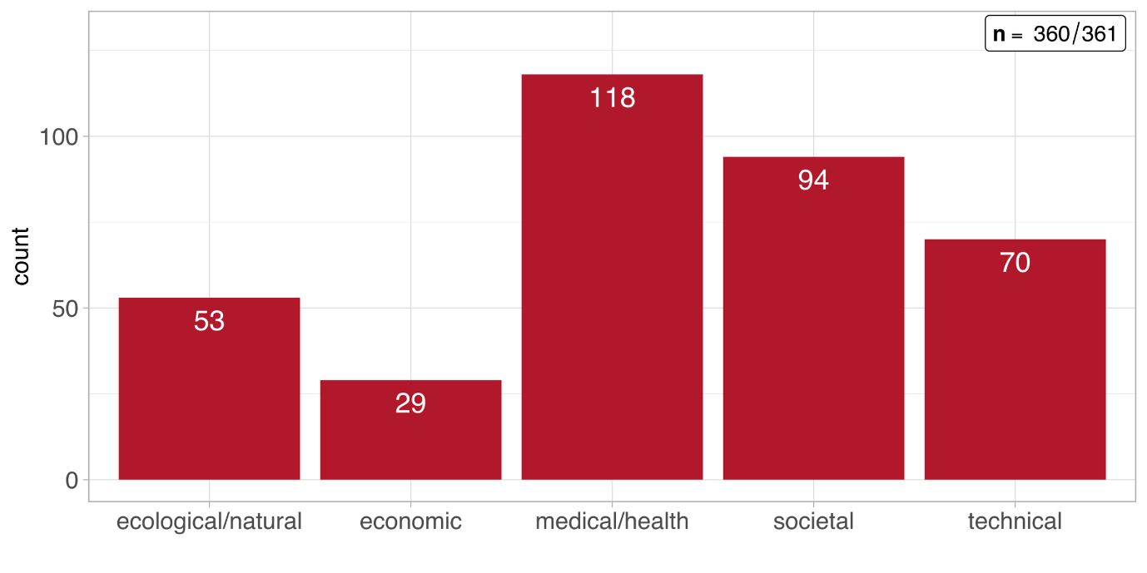

Table 9: Distribution of impulses from the non-academic world (multiple choice)

|  |  |  |
| --- | --- | --- |
| **response** | **abs** | **%** |
| **a specific societal problem** | 94 | 26.04% |
| **a specific economic problem** | 29 | 8.03% |
| **a specific ecological/natural problem** | 53 | 14.68% |
| **a specific health/medical problem** | 118 | 32.69% |
| **a specific technical problem** | 70 | 19.39% |
| **Other** | 62 | 17.17% |

Goals with regard to target groups

Figure 16: Distribution of target group goals

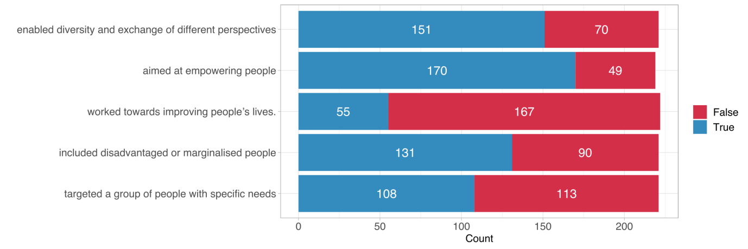

Envisioned social goals of the project can be important indicators of social innovation. Several true/false statements concerning foreseen social impact or social inclusion goals were raised to measure further aspects of transdisciplinarity. *Aim to empower targeted or included social groups* was the most frequently selected category (170 times) followed by *enabling diversity and exchange of different perspectives* (151 times). The category the *project worked towards improving people’s lives* was the least frequent selected category (55 times).

Table 10: Distribution of target group goals

|  |  |  |  |  |
| --- | --- | --- | --- | --- |
| **Goal** | **no** |  | **yes** |  |
|  | **abs** | **%** | **abs** | **%** |
| **targeted a group of people with specific social needs (n= 221)** | 151 | 68.33% | 70 | 31.67% |
| **included socially disadvantaged or marginalised people (n=219)** | 170 | 77.63% | 49 | 22.37% |
| **worked towards improving people’s lives (n=222)** | 55 | 24.77% | 167 | 75.23% |
| **aimed at empowering people (in general or specific groups) (n=221)** | 131 | 59.28% | 90 | 40.72% |
| **enabled diversity and exchange of different perspectives (n=221)** | 108 | 48.87% | 113 | 51.13% |

Intended Effects

In the online survey, we inquired about intended changes to investigate potential project outcomes, both in the long and short term. We differentiated four categories of effects: (i) improving understanding as most generic effect of scientific research; (ii) raising awareness of an issue; (iii) changing attitude, which has a normative change connotation, and (iv) changing behaviour, which has an action-oriented connotation.

*Improving the understanding* as well as *raising awareness* in the general population is by far the most frequently selected category (79 and 50 times respectively; cf. Figure 17 and Table 11). Other arguably stronger types of changes (attitude and behaviour) are occurring relatively less frequent among all of the defined societal actor categories. However, 31 respondents noted that the intended effect (or one of the intended effects) of their research project was a behavioural change among policymakers and/or public administration.

Figure 17: Distribution of intended change

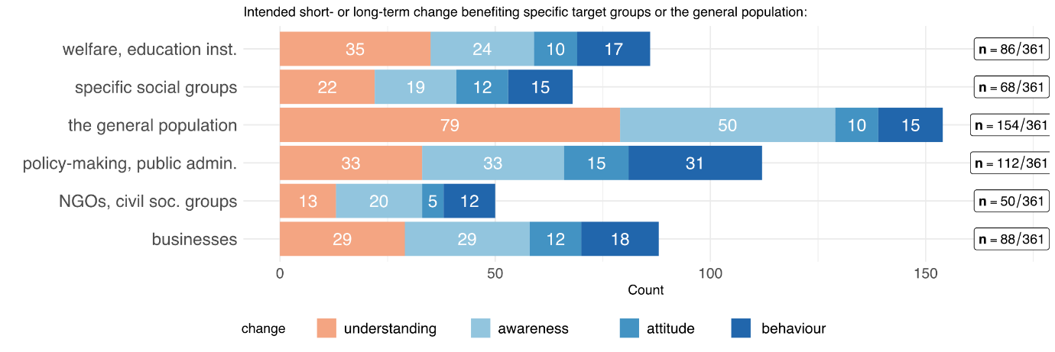

Table 11: Distribution of intended change

|  |  |  |  |  |  |  |  |  |  |  |
| --- | --- | --- | --- | --- | --- | --- | --- | --- | --- | --- |
|  | **Changing …** | | | | | | | | | |
| **Target audience** | **under­standing** | | **awareness** | | **attitude** | | **behaviour** | | **other** | |
|  | **abs** | **%** | **abs** | **%** | **abs** | **%** | **abs** | **%** | **abs** | **%** |
| **the general population (n=170)** | 79 | 46.47% | 50 | 29.41% | 10 | 5.88% | 15 | 8.82% | 16 | 9.41% |
| **businesses (n=100)** | 29 | 29.00% | 29 | 29.00% | 12 | 12.00% | 18 | 18.00% | 12 | 12.00% |
| **specific social groups (n=73)** | 22 | 30.14% | 19 | 26.03% | 12 | 16.44% | 15 | 20.55% | 5 | 6.85% |
| **welfare- and education-providing institutions (n=93)** | 35 | 37.63% | 24 | 25.81% | 10 | 10.75% | 17 | 18.28% | 7 | 7.53% |
| **NGOs, advocacy or other civil society groups (n=53)** | 13 | 24.53% | 20 | 37.74% | 5 | 9.43% | 12 | 22.64% | 3 | 5.66% |
| **policy-making, public administration, governmental agencies (n=117)** | 33 | 28.21% | 33 | 28.21% | 15 | 12.82% | 31 | 26.50% | 5 | 4.27% |
| **academia (n=312)** | 219 | 70.19% | 32 | 10.26% | 21 | 6.73% | 28 | 8.97% | 12 | 3.85% |

**Efforts for change and impact**

Another crucial aspect of social innovation is its strive for change and impact. This change can happen on several levels and affect different stakeholders or groups:

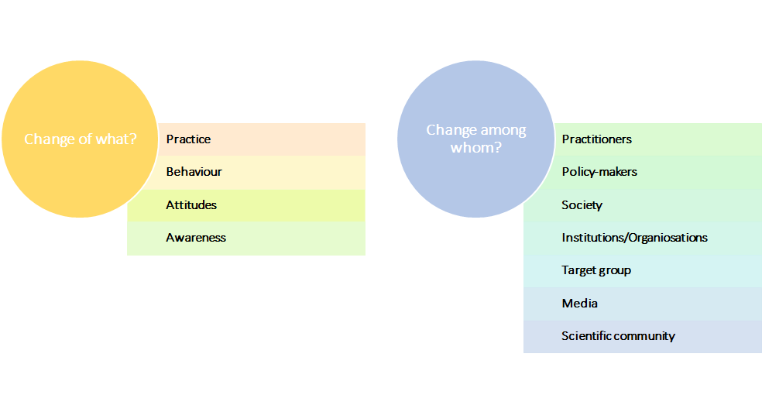

### Change of what?

1. **Change in practices:** One aspect of change is the change in practices. Practices can be seen as something that is performed regularly or habitually, such as actions that are perceived as standard in a given field. Several research projects aimed at changing practices. For example, some interviewees reported that the objective of their research was to change the way medical treatment is executed or how and in which situations doctors prescribe drugs. Others emphasized that their aim was to change political decision-making or the training for practitioners. While in many cases, this change in practices was an explicit goal of several projects, it was highlighted that this change only takes place incrementally over a longer period of time. Furthermore, a change in practice is often related to and follows a change in, for example, attitudes and behaviour. Hence, achieving a transformation of practices can be a complex and long process. However, it has great potential for social innovation.
2. **Change in behaviour:** Very similar to a change in practices is a change in behaviour. The difference is that while practices refer to “the customary, habitual, or expected procedure or way of doing something”[8], behaviour is defined as “the way in which one acts or conducts oneself, especially towards others”[9]. While the definitions differ, a clear differentiation is hard, especially since behaviour often results in practices when done frequently. For instance, one interviewee said that one of his goals was to achieve a reflexive process for practitioners which should ultimately change their behaviour in certain situations. However, he also stressed that once this behaviour change is incorporated, this could also result in a change of practices. This again highlights the interconnectedness of behaviour and practice.
3. **Change in attitudes:** A lot of projects did not have the intention to initiate a change in practices or behaviour. Rather, their goal was to change the attitudes of a given sub-population or wider society. For instance, one interviewee who studied the effects of migration on housing and segregation argued that one important aspect that prohibits societal change is the attitude of policy-makers as well as the public. Accordingly, different stakeholders perceive recent migration flows as negative and potential for conflict, while this was not necessarily the case with past migration flows. Hence, most often, a change in attitudes and perceptions is essential when trying to achieve a change in behaviour or practices. Accordingly, when trying to accomplish a broader impact, it is also crucial to keep people who might not be obvious stakeholders (e.g., society as a whole) in mind. One interviewee, who worked on the medical treatment with antidepressants, stated:

*“Another, further social component is the population's broad perception of psychotropic drugs. They are viewed critically in broad sections of the population, and I think part of this criticism also comes from the fact that they are not discontinued. A social component that is important for me is that this concern, this perception is addressed, and that it is perceived and taken up.” Interviewee 7*

1. **Change in awareness:** Another aspect that can be suspect to change is awareness. One-third of the interviewees said that one of their aims was to raise awareness regarding their research problem. This awareness-raising was either targeted at a specific group (e.g., decision-makers, institutions, businesses/industries) or directed at society at large. Again, the differentiation between a change in awareness and a change in attitude is often hard to make. One interview partner, for example, mentioned that in order to raise awareness amongst society, it is necessary to change the attitude of the media when reporting about an issue at stake. Accordingly, the interviewee stated that when working on a highly polarized problem, the press tends to have a hardened opinion towards this problem. This, however, influences both the attitude of society toward this problem as well as hinders the possibility to raise awareness about certain aspects of the issue. However, a change in awareness is also often connected to a change in practices and hence can enhance or limit the opportunities for social innovation. Another interviewee summarised the link between a change in awareness and practices in the following way:

*“I wouldn't say / it's still far from over, it's really hard to say what will really work and what won't, but that will probably be even more intense in the next few years because there are new areas. But what I can say is I believe that this continuous discussion between researchers, between doctoral students, other researchers and authorities and residents, so to speak, the awareness of the problem of how these processes are to be designed at all and the interest in adapting formats, new formats trying out, looking for new forms of dialogue, that we at least make our contribution from the research side.” Interviewee 9*

### Change amongst whom?

As highlighted above, the change can affect either one or several different groups.

1. **Practitioners:** About one-fourth of all interviewees said the change they intended was addressed to practitioners. While practitioners differed vastly in their background, most researchers had a similar concept of including them in their study. Correspondingly, it was stressed that when trying to achieve a change in practitioners, it is crucial to meet them on an equal level. This encompasses finding a common language, avoiding a too scientific narrative and building trust. Moreover, the exchange should be a mutual dialogue rather than a one-sided information provision. Hence, including practitioners in a project brings many challenges. Yet, all interviewees who included practitioners in their research highlighted that including practitioners is a very effective way to achieve change as they directly influence structures within a system and most often have the power to influence both the discourse around a topic as well as other stakeholders.
2. **Policy- and decision-makers:** Policy- and decision-makers can also be the target of change. One interview partner highlighted that in order to change norms and attitudes in the “practical world”, policy-makers need to be addressed directly as they significantly influence everyday practices by implementing policies and regulations. Similarly, several interviewees stressed that in many cases, structural change could only take place when politicians have a better understanding of the situation within institutions and organisations and “good policy-making" depends heavily on the information that decision-makers have.
3. **Society:** Society was an important aspect of change in many studies. While most PIs did not specifically mention the role of society in the project and vice versa at the beginning of the interviews, almost all of them mentioned that society is either directly or indirectly affected by the research during the course of the conversations. Hence, although the impact society has on the research or the research has on society, this impact might not be immediately visible. However, in many cases, society cannot be excluded from the broader picture as research phenomena do not only concern immediate stakeholders and target groups. One interviewee emphasized that while its direct aim was to change the practices of public authorities, it was also essential to raise awareness amongst the wider society as this is indirectly linked to what is seen as appropriate or inappropriate.
4. **Institutions/Organisations:** National and international organisations were also named as an important subject of change. Accordingly, one interviewee, who dealt with pollution, stressed that international organisations (e.g., the UN) have enormous influence and power when it comes to norms and regulations on a global level. Hence, including such organisations in the change process is, in many cases, extremely important for researchers. Another interviewee worked together with national associations with the aim to raise their awareness concerning intra-country disparities concerning field-specific practices in Swiss cantons. He stressed that often these authorities are too busy to engage with what happens in other cantons, which leads to differing quality in services provided. Hence, bringing these stakeholders together at conferences or colloquia can foster exchange and learning.
5. **Target group:** Transformative intentions can also be targeted at a projects’ target group. On the one hand, interviewees mentioned that projects could have an empowering element, through which target groups are able to engage with other stakeholders and are ultimately part of the debate they are affected from. On the other hand, projects can have a reflexive element for participants. One interviewee reported that she presented the data (e.g., recorded videos) and preliminary findings to the participants of the projects. This allowed them to reflect on their behaviour and talk about it to the researcher as well as other participants.

*“[P]articipation procedures made them think about that by themselves and this is a way that I would call that a form of empowerment in the sense, it is not me going to them and saying, "look, you are doing badly here", but I just show what they do, I show the consequences of, also minor details of their practice and their consequences and in general, this produces their own conclusions, or consequences, and I think that this is a way much better, because you keep them to analytical tools that they can a way apply to themselves, rather than giving them normative principles or normative recipes, and I always reframe from the / yes, recipes or prescription or this kind of things.” Interviewee 2*

1. **Media:** The media was also identified as an important actor of change. According to several interviewees who dealt with highly controversial topics, the media shapes the narrative surrounding this topic in a very biased way. Hence, approaching them directly and trying to include them in the project can at least partly contribute to a communication based on scientific results. Moreover, the power of the media to influence society at large but also politicians was underlined. One interviewee mentioned that one way to change the practices of decision-makers is to bring the media to report about projects and academic insights in order to raise awareness and interest among policy-makers:

*“[M]edia sometimes can exert pressure, at least by creating a debate and creating sometimes social movements, and so we always hope that this will exert some pressure on policymakers.” Interviewee 3*

1. **Industry:** A few projects also tried to directly evoke change in the industry. Accordingly, it was highlighted that although fundamental research has often limited direct impact on the industry, it can offer essential insights that might, in the long run, result in changes within a certain industry. Furthermore, including industry partners as possible actors of change can benefit both sides. On the one side, understanding the needs and challenges industries face can advance academic research. On the other hand, the industry can benefit both from academic knowledge directly but also from sustaining exchanges as they are then able to establish contacts that might prove to be valuable for future projects.
2. **Scientific community:** Some interview partners also mentioned their aim to change parts of the ways academic research is conducted. One interviewee, for example, highlighted that one of the novelties of her project was the interdisciplinary aspects which are not common in her field. Accordingly, she made great efforts to spread the benefits of cross-disciplinary research amongst other scientists formally by giving talks at conferences but also informally by reporting about her experiences to colleagues whenever possible. Hence, transformative actions do not always need to be targeted at non-academic actors. Rather, a combination of changes within and outside of academia can prove most successful when aiming for social innovation.

Most interviewees stated that intended change is directed at more than one group within the same project, some of which are easier to reach than others. One interviewee pointed out that it is necessary to bring the target group and decision-makers to the same table in order to be able to design needs-based policies. This demands a continuous dialogue, which is not easy to create and sustain:

*“What we notice is that from all these discussions, at least on the part of the city, the question of how this whole communication process has to be designed has been discussed again and again, new formats have always been tried out, well, I can see that, that's it such a continuous process of dialogue between those doing the research on the one hand, those affected on the other and the city authorities on the third side, and I have already noticed that this/this feedback, the reflection, so to speak - what is happening there , which groups are there, why certain groups don't come to the events, why don't certain groups take part in the discussion, that this leads to the city thinking about this process relatively intensively.” Interviewee 9*

**Obstacles for change**

1. **Nature of politics:** Several interviewees highlighted political constraints. One aspect that was highlighted was the pressure that politicians experience. For example, when dealing with topics concerning migration, there are enormously different interests within the political arena which makes it difficult for academics to firstly bring all crucial stakeholders together and secondly, bring all stakeholders to agree on the topic. Similarly, several interviewees highlighted that the multi-level governance of Switzerland makes it hard to achieve change on a political level. For example, one interviewee working on health care reported that although he managed to sit down with decision-makers on the upper end of the governance hierarchy, it was hard to accomplish a change of political practices as municipalities ultimately translate policies into action. Another issue that was highlighted is the vastly different approaches in academia and policy-making. Accordingly, academic research often employs sophisticated methods that are hard to understand for people outside academia. Hence, transferring academic results into more understandable language is crucial when trying to engage with policy-makers.

Moreover, interviewees stressed that political will is often connected to particular people in the office. Since it is often the case that people leave office, topics that were interesting for the competent body can become irrelevant to successors. This makes it difficult for researchers to contribute to long-term change. Generally, several interview partners underlined the often limited interest from policy-makers for certain topics. One interviewee stressed that his topic (the prevention of an epidemic caused by a certain strand of bacteria) was not seen as urgent enough by policy-makers to implement actions as the last outbreak of the related illness lies decades behind.

1. **Nature of academia:** Another barrier to change that has been identified by many interviewees is the nature of academia. This barrier can further be broken down into several aspects. First, academic research tends to be very slow and takes time to produce publishable and presentable results. Especially in fundamental research, interviewees stressed that the road to impact is extremely long and can be tedious at times since the academic system is not geared towards generating immediate results. One interview partner said she would have the opportunity to “work quick and dirty” in order to create immediate outcomes. However, good research requires a researcher to be thorough and conscientious. Similarly, one interviewee criticises the pressure to publish within academia. Correspondingly, both the quality of the research but also the possible impact it could have outside of academia are compromised in order to meet publication criteria:

*“Unfortunately, the young people who have followed me have paid the consequences because they are convinced of the importance of a complex research design that requires a non-negligible sample. What does it matter? If you spend your time collecting data, you don't publish. And at the moment, we publish, publish, publish, to the detriment of the quality of the research and to the detriment of this type of research.” Interviewee 15*

Another aspect is related to fundamental research. According to many of the PIs, who conducted fundamental rather than applied research, the potential impact of their research was limited by the nature of the research design. Accordingly, one interviewee said that in contrast to applied research, basic research tries to be more explorative and less tailored to finding a specific solution. Hence, the social impact of fundamental research is often limited to an indirect effect. Another related aspect is a systematic barrier regarding the right to award doctorates. For example, in arts or at teacher training colleges, there are no opportunities for PIs to employ doctoral students. However, according to several interviewees, both academic research and also the transfer from science to practice since if PIs could then rely on academic staff rather than relying on “third-party universities that are authorised to award doctorates”.

1. **Nature of the economy:** Another systematic barrier that has been pinpointed by a few interviewees is the nature of the economy. One interview partner, for instance, emphasized that the impact of her project, which tried to analyse gender disparities in a specific sector of the economy, was limited because of the general structure of the economy. More specifically, she tried to find solutions for overcoming gender inequalities in a certain industry which are also connected to the wider functioning of the economy and labour market (e.g., unequal pay or disparities in paid vs. unpaid work). She hence highlighted that far-reaching change would have only been possible when those structures are addressed by a wide range of actors, such as local and national policy-makers. Other interviewees highlighted the different functioning of the economic and the academic system. Accordingly, findings that have been produced within the academic spheres are often not immediately translatable to industry. Yet, industry partners often require easy understandable and accessible results and outcomes, otherwise, they could lose interest in the project.
2. **Commercialisation:** A similar barrier to the nature of the economy is the commercialisation of a product or service. Research projects that are more fundamental often face the problem that businesses are not interested in the results since they are often not easily or readily transferable to the industry. Similarly, findings that are produced by basic research often are perceived as a risk by the industry as they are not yet tested in “the real world”. On the other hand, researchers that conducted fundamental research and tried to transfer their outcomes to a certain industry claimed that greater change could only have been achieved if the product or service had been commercialised. Commercialisation is not only linked to making a product accessible to wider society but also brings the opportunity for bigger investments by firms which in turn enables researchers to improve a product. One researcher summed the issue of commercialisation up in the following way:

*“If you want to achieve an impact, if you want this to become a real product, you need to make a company, you need to get eventual capital, otherwise it is not going to work.” Interviewee 5*

1. **Legal issues:** Furthermore, some interviewees highlighted legal constraints. Aspects related to this were mentioned were, for example, access to sensitive data, the sharing of data and issues of accountability and responsibility. Accordingly, an effort for change can be undermined when regulations do not allow access or sharing of data that would be necessary to better understand a problem and to communicate in-depth- results rather than generalizations. Another interviewee mentioned the complex regulations (e.g., in health care and hospitals) of who funds what and who is responsible for what. This system complicates change by making it hard for researchers to understand the entangled web of rules and regulations but also by directly opposing actions.
2. **Resources (time, money, energy):** Several interviewees highlighted limited monetary resources as a restrictive element of change. For example, a few interview partners mentioned that certain disciplines receive more funding (e.g., explicitly for making results usable) while other, less applied fields receive less or struggle to win grants that allows them to be more applied. Others emphasized the general lack of monetary support since many projects rely on external funding, which is not always easy to acquire. More specifically, this heavy reliance on funding schemes was seen as limiting the effects a single project can have. Accordingly, funding that finances a project of three or four years often ignores the intertwined nature of research and knowledge, which follows more of a circle than a straight line. Moreover, the role of networks within funding institutions and the diversified landscape of those organisations was seen as obstructive.

*“Yes, I mean that would of course be a question, with an SNF project like this, you do it, you get funded - for which I'm extremely grateful, but when that's over, it's also over and the / as soon as there's a slight shift in the sponsoring institutions, you're very quickly out of the networks again and there it is, the project funding is not very sustainable, basically, because it's then strongly attached to the institutions.” Interviewee 2*

Furthermore, time and energy were identified as restraining factors for change. As already mentioned, a lot of interviewees stress that the pressure to publish in academia is relatively high, which leads to less time for other activities. Similarly, several interview partners emphasised the situation of young researchers in academia who struggle to find long-term or permanent employment and face fierce competitive pressure. Hence, neither senior nor young researchers often have the time to spend more time than necessary on implementing outcomes if such activities go beyond the scope of their project.

1. **Dissemination:** Dissemination was also perceived as troublesome for achieving impact. A few interviewees noted that scientists are often bad ad communicating their results to a broader public, more specifically to a non-academic audience. One aspect that was highlighted is that dissemination is often limited to either limited to the academic community or, as is often the case in international research projects, to national stakeholders. One interviewee argued that often researchers work with target groups outside of their home country, do not, however, report back the results to relevant stakeholders to the country the research was conducted in:

*“And that is what I found, perhaps in a deep sense this is also a problem of the scientific community, especially in these development contexts, that one, so to speak, with one's own motivation. That one wants to earn one's own salary and have a good life in Switzerland, in Austria - one goes to the slums, because there you can collect good primary substances and with that you run back home, tell great stories and the impact on the ground is actually non-existent or even extractive, or, in other words, that you take people's time away, or also with the hope that something would improve and effectively nothing ever flows back.” Interviewee 16*

Another aspect that hampers dissemination is the limited control of the dissemination process itself. One interviewee, for instance, mentioned that while direct communication (e.g., at conferences) works quite well, this is often not the case when intermediaries, such as the media, are involved. Accordingly, when dealing with vulnerable groups or disputed topics, researchers have to be careful with their articulation and whom they talk to in order to avoid misunderstandings. This, however, can limit the promulgation of project findings. Additionally, the restrained interest from the public was highlighted. This lack of interest is further exaggerated by the fact that a lot of project outputs (e.g., reports) are written in English, which reduces the size of the target audience.

Lastly, several interview partners emphasize the role of the expectations you have when disseminating results. Accordingly, one interviewee, for instance, stressed that while social science is extremely useful and necessary, the impact that researchers can have to achieve a bigger impact is limited in general. More specifically, a researcher’s role is to contribute to such a change. However, one single project can only achieve so much. Another interviewee highlighted the importance of networks when it comes to dissemination. Appropriately, knowing the actors when communicating the results can be crucial for successful dissemination. Yet, the interviewee also stressed that even when you have invested time and energy to get to know relevant actors, the impact you can accomplish is limited.

*“Well, if you want to achieve something, you have to spend a long time getting to know the actors in the field, you have to understand what they are concerned about, you have to build up trust, you have to spoon in new ideas and after a lot of effort, sometimes after years, in the best case you have a context - now with my last project, which I have just completed - where you can work together joyfully and perhaps achieve something, but even then you have to be modest in the end.” Interviewee 16*

1. **Transdisciplinarity:** Some researchers highly depend on the exchange with non-academic stakeholders for their research. While this can have many advantages for academia, it also poses some challenges. For example, it was argued that when the research field is highly politicized or includes vulnerable groups, one has to be careful both in terms of what is said in general and whom else interactions take place with. Hence, the social impact might be limited because researchers act within an arena with a high potential for conflict, which often forces them to juggle different interests.

Others mentioned that differing interests of stakeholders hinder the impact of a project. One researcher reported that while policy-makers were extremely interested in his project idea, practitioners were sceptical since the project involved the support of humanoids. Moreover, several PIs mentioned the role of traditions when working with stakeholders. Accordingly, many involved actors rely on practices that have been well-known in the field for decades. Hence, stakeholders can be very suspicious of researchers who try to change certain norms or habits. Similarly, it was highlighted that researchers need experience in the communication and exchange with stakeholders since they operate with a completely different knowledge base. Others stressed that relevant actors were not included early enough, or it was generally difficult to build up a network of interested stakeholders. More details regarding the challenges of transdisciplinarity can be found in the next chapter.

**Failed actions for change**

There were also instances where the effort for change remained unsuccessful. The reasons for this were manifold and loosely relate to the obstacles to change discussed above. Most of the statements that can be attributed to failed actions for change can be summarised in four categories.

1. **Dissemination failed:** Almost every fifth interviewee mentioned those dissemination activities proved to be unsuccessful, which led to only a minor or no impact outside of the project framework. For example, one PI highlighted that the project team tried to initiate an exchange with policy-makers who, after one short presentation, were not interested in further interactions. Another interviewee said that she tried to make the results of her project publicly available by working together with the media. Although she expected further communication with other outlets or reactions from the public, the feedback from the media and society remained small.
2. **Fundamental research project did not go far enough:** As already discussed, several interviewees stressed that their project did not evoke any change because of the nature of their project; for example, because projects were fundamental research. While the outcomes proved to be valuable for academia as well as in some non-academic spheres, interviewees stressed that results were either too narrow or not applied enough to find broader usage. This statement is not only limited to social sciences, but also PIs coming from natural sciences stressed that their outputs (e.g., prototypes) were not taken up by wider stakeholder groups since it would have required a different approach within the project setting (i.e., more focus on a practical side).
3. **Results are not taken up:** Similarly, interview partners mentioned that results were not taken up by relevant stakeholders. This strongly relates to the previous two points of failed dissemination and the nature of the project. Correspondingly, dissemination and an appropriate project design (e.g., with an explicit focus on the communication of findings or the application outside academia) can help to create transformations in more practical settings.
4. **The issue is too complex:** A few researchers mentioned that the complexity of the research phenomenon makes structural or long-term change difficult to achieve. This could, for example, be because of the broad stakeholder landscape or because the phenomenon consists of or is influenced by many factors. According to some interviewees, one research project is not able to create enough impact to realize change. Rather, it is part of many elements that incrementally foster transformative processes.

*“So, bringing about change is a huge process, which itself needs a lot of analysis, in each individual case different forms of interaction and intervention and a high level of willingness on the part of the practitioners themselves to really change something, and mostly the big difficult problems.“ Interviewee 16*

5.2 Actual outcomes and limitations

Our proposal aims to trace contributions of research funded by SNSF to social innovations, and to systematise these contributions in a valuation framework. In addition, we aim to identify to what extent contributions to social innovation in SNSF-funded research projects are possible at all, and where further support measures, either provided by SNSF or from outside (e.g. by the universities), could create an added value that could not be tapped so far.

Direct contributions to target group(s)

Research projects funded by SNSF rarely contribute directly to new services, products, or processes. Although the majority of respondents marked 3 or lower on a 0-10 scale for all of the specific categories (see Figure 18), ~ 40 % of the respondents noted that their project results somewhat directly contributed to new/better products and services for the general population. 18 % of respondents even stated to have strongly contributed to benefit the general population (cf. Table 12).

Our definition of SI encompasses outcome-orientation, both tangible and non-tangible. In other words, if the intention to achieve impact is missing, then a constitutive element that characterises social innovation is missing too. This does not mean that the project may not have contributed to social innovation in the end. However, from a definitional point of view, it does not correspond to the intentional understanding of a social innovation.

Figure 18: Direct contribution to target group(s)

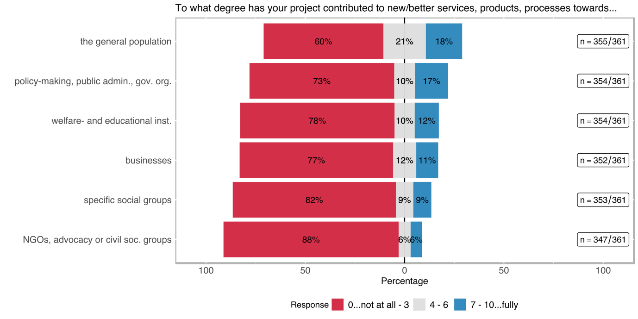

Table 12: Direct contribution to target group(s)

|  |  |  |  |  |  |  |  |  |  |  |  |  |  |  |
| --- | --- | --- | --- | --- | --- | --- | --- | --- | --- | --- | --- | --- | --- | --- |
|  | **the general population (n=355)** | | **busi­nesses (n=352)** | | **specific social groups[10] (n=353)** | | **welfare- and education-providing institutions[11] (n=354)** | | **NGOs, advocacy or other civil society groups (n=347)** | | **policy-making, public admini­stration, govern­mental agencies (n=354)** | | **academia (n=357)** | |
| **re­sponse** | **abs** | **%** | **abs** | **%** | **abs** | **%** | **abs** | **%** | **abs** | **%** | **abs** | **%** | **abs** | **%** |
| **0** | 116 | 32.68 | 177 | 50.28 | 223 | 63.17 | 200 | 56.50 | 241 | 69.45 | 185 | 52.26 | 29 | 8.12 |
| **1** | 26 | 7.32 | 32 | 9.09 | 30 | 8.50 | 32 | 9.04 | 27 | 7.78 | 26 | 7.34 | 3 | 0.84 |
| **2** | 39 | 10.99 | 36 | 10.23 | 24 | 6.80 | 21 | 5.93 | 22 | 6.34 | 25 | 7.06 | 8 | 2.24 |
| **3** | 33 | 9.30 | 27 | 7.67 | 13 | 3.68 | 22 | 6.21 | 16 | 4.61 | 22 | 6.21 | 8 | 2.24 |
| **4** | 15 | 4.23 | 13 | 3.69 | 8 | 2.27 | 13 | 3.67 | 7 | 2.02 | 11 | 3.11 | 10 | 2.80 |
| **5** | 40 | 11.27 | 24 | 6.82 | 13 | 3.68 | 12 | 3.39 | 10 | 2.88 | 20 | 5.65 | 27 | 7.56 |
| **6** | 21 | 5.92 | 4 | 1.14 | 10 | 2.83 | 11 | 3.11 | 4 | 1.15 | 6 | 1.69 | 16 | 4.48 |
| **7** | 21 | 5.92 | 9 | 2.56 | 11 | 3.12 | 14 | 3.95 | 9 | 2.59 | 22 | 6.21 | 46 | 12.89 |
| **8** | 22 | 6.20 | 11 | 3.13 | 10 | 2.83 | 14 | 3.95 | 3 | 0.86 | 19 | 5.37 | 59 | 16.53 |
| **9** | 5 | 1.41 | 6 | 1.70 | 4 | 1.13 | 6 | 1.69 | 3 | 0.86 | 5 | 1.41 | 41 | 11.48 |
| **10** | 17 | 4.79 | 13 | 3.69 | 7 | 1.98 | 9 | 2.54 | 5 | 1.44 | 13 | 3.67 | 110 | 30.81 |

Uptake by decision-makers

The uptake of the project results by decision-makers is one of the indicators of project outcomes. The survey was designed to explore this aspect using two different questions, which were mainly aimed to measure how far the project results have been adopted by the authorities and what was the nature of the uptake.

Figure 19: Uptake of project results by policy-makers

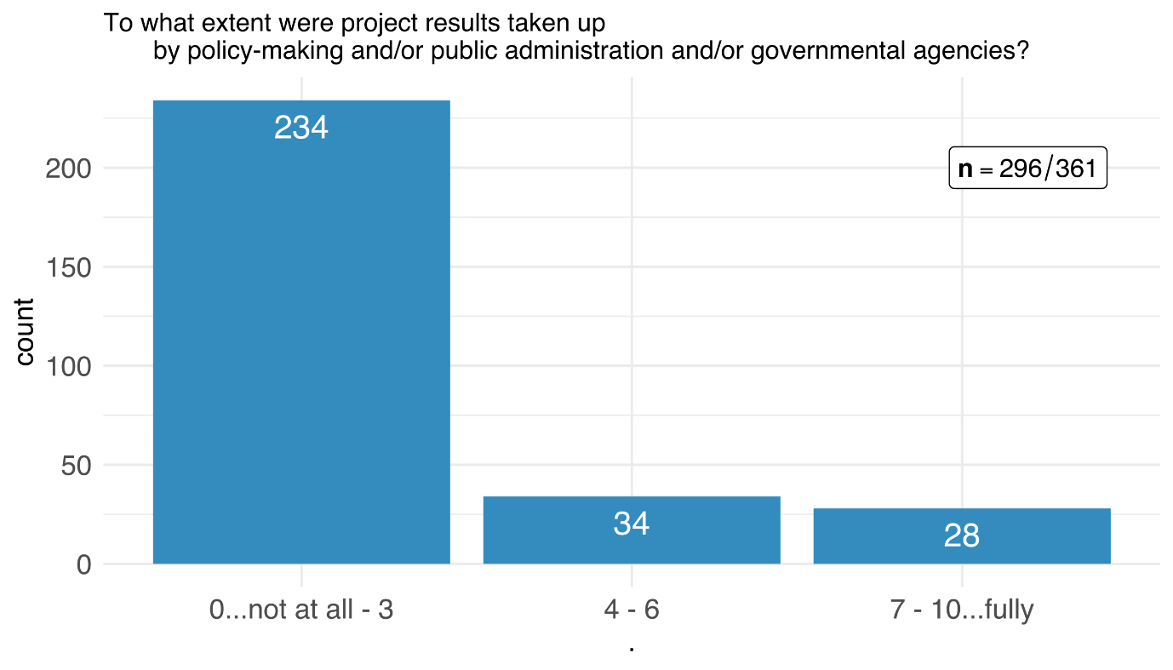

Approximately 20 % of the respondents rated the *uptake of the project results by decision-makers* moderate to high (see Table 13). However, an overwhelming majority of the respondents reported that there was little to no uptake of the project results by policy-makers, public administration, or governmental agencies.

Table 13: Uptake of project results by policy-makers

|  |  |  |
| --- | --- | --- |
|  | **adopted by policy (n=296)** | |
| **response** | abs | % |
| **0** | 153 | 51.69% |
| **1** | 22 | 7.43% |
| **2** | 42 | 14.19% |
| **3** | 17 | 5.74% |
| **4** | 9 | 3.04% |
| **5** | 15 | 5.07% |
| **6** | 10 | 3.38% |
| **7** | 9 | 3.04% |
| **8** | 12 | 4.05% |
| **9** | 2 | 0.68% |
| **10** | 5 | 1.69% |
| ***not applicable*** | *57* |  |
| ***no response*** | *8* |  |

Figure 20: Kind of uptake of project results by policy-makers

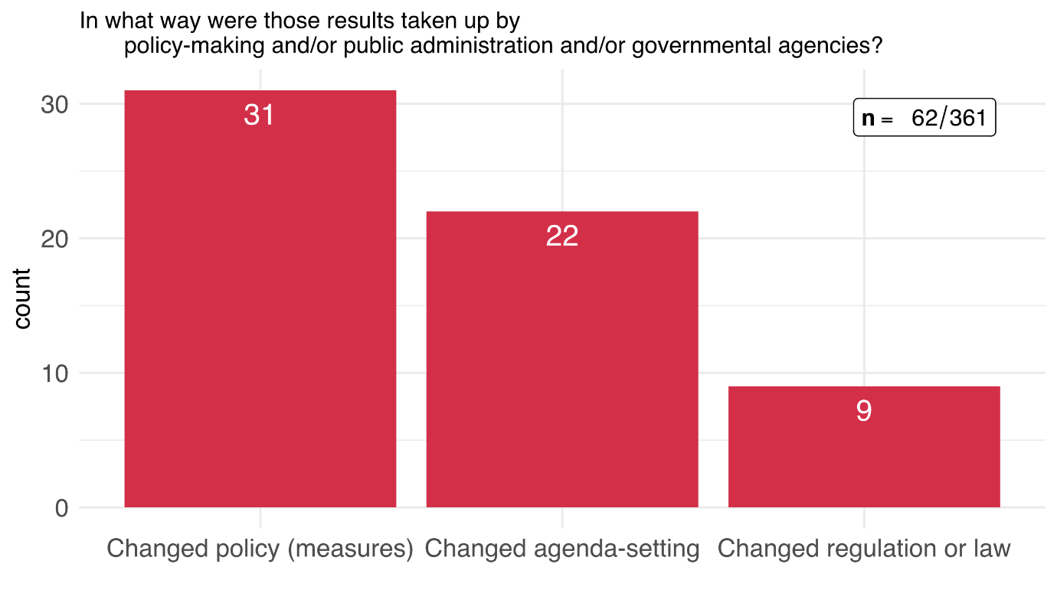

The nature of the policy uptake indicates what kind of a change the uptake by policymakers and public administration caused. Nine respondents claim that the results of their projects changed/influenced laws and regulations, 22 respondents note that the results changed specific agenda-settings and 31 reported about changed policies (i. e. changes in policy measures) (see Figure 20). This means that 17 % of the SNSF funded projects had an impact on policy or public administration, mostly in the way how policies or policy measures are designed and implemented.

Table 14: Kind of uptake of project results by policy-makers

|  |  |  |
| --- | --- | --- |
|  | **Nature of uptake by policy-makers (n=62)** | |
| **response** | **abs** | **%** |
| **Changed policy (measures)** | 31 | 34.83% |
| **Changed agenda-setting** | 22 | 24.72% |
| **Changed regulation or law** | 9 | 10.11% |
| ***Other*** | *27* |  |

Impact statements

Figure 21: Impact statements – change affected through the funded research project

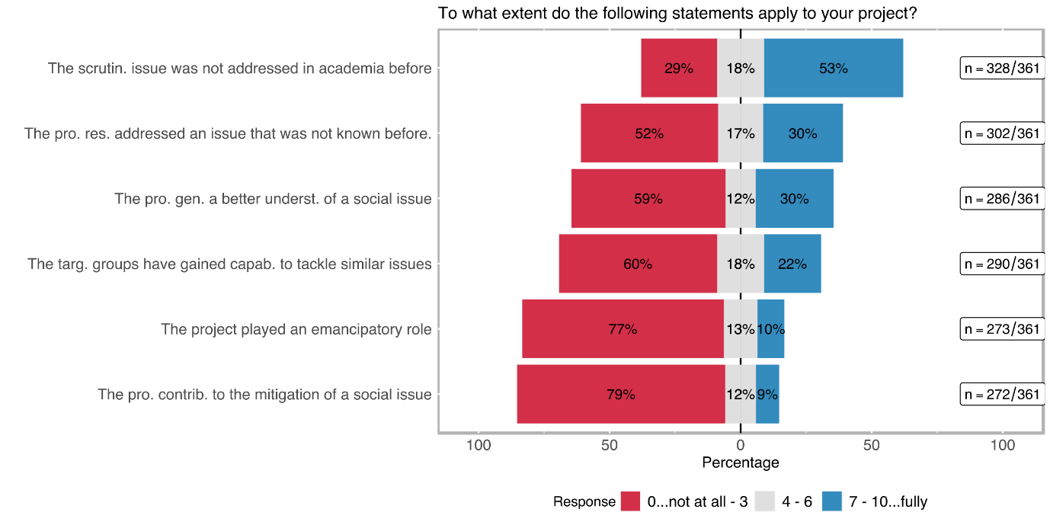

The last question in the outcome orientation section of the survey focused on impact statements and how the impacts of the scrutinised SNSF-funded projects corresponded to these statements. The statements are chosen to address SI-relevant aspects directly.

The academic dimension was by far the highest-rated statement among the survey respondents (see Figure 21), 53 % of the respondents rated the statement *the scrutinised issue was not (widely) addressed in academia before* 7 or higher on a scale from 0 to 10 (cf. Table 15).

This result is followed by a similar statement *the project results addressed an issue that was not (widely) known before* which was specifically directed to the novelty of the issue for the public, 30 % of the respondents rated this statement 7 or higher.

The statement that *the project generated a deeper/better understanding of the social issue* was rated similarly by the respondents. It is striking that as many as 10 % and 9 %, respectively, of the SNSF-funded projects contributed to an *emancipatory impact* or the *mitigation of a social issue*.

Table 15: Impact statements – change affected through the funded research project

|  |  |  |  |  |  |  |  |  |  |  |  |  |
| --- | --- | --- | --- | --- | --- | --- | --- | --- | --- | --- | --- | --- |
|  | **capacity to tackle similar issues (n=290)** | | **Emancipa­tion (n=273)** | | **deeper/ better understan­ding of a specific social issue (n=286)** | | **mitigation of a social issue (n=272)** | | **issue not (widely) known in the society (n=302)** | | **issue not (widely) addressed in academia (n=328)** | |
| **response** | **abs** | **%** | **abs** | **%** | **abs** | **%** | **abs** | **%** | **abs** | **%** | **abs** | **%** |
| **0** | 105 | 36.21 | 142 | 52.01 | 117 | 40.91 | 155 | 56.99 | 102 | 33.77 | 62 | 18.90 |
| **1** | 22 | 7.59 | 22 | 8.06 | 22 | 7.69 | 28 | 10.29 | 17 | 5.63 | 10 | 3.05 |
| **2** | 26 | 8.97 | 26 | 9.52 | 10 | 3.50 | 17 | 6.25 | 13 | 4.30 | 8 | 2.44 |
| **3** | 22 | 7.5% | 20 | 7.33 | 19 | 6.64 | 16 | 5.88 | 26 | 8.61 | 15 | 4.57 |
| **4** | 18 | 6.21 | 11 | 4.03 | 12 | 4.20 | 8 | 2.94 | 17 | 5.63 | 16 | 4.88 |
| **5** | 19 | 6.55 | 15 | 5.49 | 9 | 3.15 | 16 | 5.88 | 19 | 6.29 | 25 | 7.62 |
| **6** | 15 | 5.17 | 9 | 3.30 | 12 | 4.20 | 8 | 2.94 | 16 | 5.30 | 18 | 5.49 |
| **7** | 24 | 8.28 | 10 | 3.66 | 25 | 8.74 | 6 | 2.21 | 23 | 7.62 | 39 | 11.89 |
| **8** | 18 | 6.21 | 6 | 2.20 | 23 | 8.04 | 9 | 3.31 | 24 | 7.95 | 54 | 16.46 |
| **9** | 9 | 3.10 | 6 | 2.20 | 17 | 5.94 | 4 | 1.47 | 15 | 4.97 | 27 | 8.23 |
| **10** | 12 | 4.14 | 6 | 2.20 | 20 | 6.99 | 5 | 1.84 | 30 | 9.93 | 54 | 16.46 |
|  |  |  |  |  |  |  |  |  |  |  |  |  |

**Benefits and impacts of transdisciplinary research projects**

1. **Opening up a discourse between academia and stakeholders:** Almost all interviewees who identified transdisciplinary aspects in their projects highlighted the opportunity for dialogue and exchange. It is argued that most often, academic research happens in a vacuum while solutions in practice differ from what has been suggested by academics. Hence, bringing together people from academia but also a diverse range of non-academic stakeholders (e.g., practitioners, policy-makers, civil society) enabled both sides to communicate their knowledge and expertise and to work jointly on solutions. Such an exchange hence helps researchers and stakeholders to better understand each other while also creating common knowledge which could advance academia as well as solutions on the ground. In many cases, this transdisciplinary exchange has even led to further collaborations and common research plans.
2. **Empowering target group:** One aspect that was highlighted by many people who worked with the projects’ target group was the empowerment of this specific group. Accordingly, projects that talk about or research a certain group often fail to account for this particular groups’ perspectives, knowledge and vulnerabilities. Hence, solutions, either academic or practical, are often readily present to target groups with no to little room for co-development. For example, one interviewee stressed that the prototype produced within the scope of the project was significantly altered due to the many insights of the target group. At the same time, the vulnerable group received a chance to be heard, raise concerns and influence outcomes that directly affect them. Correspondingly, several interviewees argued that real and positive impact is only achievable when the groups affected by the specific issue are heard and included in the research process. However, it was highlighted that not only solutions or products can be improved by including target groups in research processes. Rather, the system of academia, i.e., the way knowledge is created and results are gained, can profit from an exchange with target groups.
3. **Fostering change in the non-academic world:** One aspect that was stressed by almost all interviewees who had exchanges with non-academic stakeholders was the aim to achieve an impact outside academia. Accordingly, it was emphasized that academic research can be very limited in its impact in the “practical world”. Although it was argued that one has to be realistic about the change that can be brought about, a network outside academia is essential to start this process. One particular aspect of this change process is the improvement of the usability of a product or service. More specifically, several interviewees from vastly different fields argued that without the support and feedback from non-academic stakeholders, the end product would not have been as promising.
4. **Learning about importance and perspective change:** Interactions with non-academic stakeholders opens up new perspectives and interests. Correspondingly, several interview partners emphasized that working together with practitioners enabled them to increase their knowledge about certain issues that were not on their radar before. One interviewee who worked together with practitioners from clinics stressed that these exchanges enabled him to think “outside the box” which ultimately led to an increased interest in transdisciplinary work. Another interviewee emphasized that the interactions with non-academic stakeholders fostered an “(…) innovation-push which came through learning from partners”. (Interviewee 10)
5. **Advancing academic research through the transdisciplinary exchange:** Interactions with non-academic stakeholders can improve the way research is understood and done.In one case, the transdisciplinary exchange with citizens has even resulted in the development of new research directions in academia. One interviewee underlined that through the exchanges with professionals and practitioners, her research idea emerged and developed.

*“Here we have a conception of scientific work, and this is another element which is extremely important for me. It's almost political. We're not breaking with common sense. We are not in this vision of science as an epistemological break where there will be researchers and the ordinary world. When I go into the field to understand how professionals work, I'm not going to arrive with a normative vision. (…). I'm not going to arrive with a ready-made conception of how they should work or what their value should be. The only thing I don't question is my pragmatic approach. But on the other hand, for example, my working hypotheses will emerge from my encounter with the field, from the questions that professionals ask themselves.” Interviewee 1*

While seniors emphasized the general importance of the knowledge of non-academic actors, one interviewee highlighted this importance, especially for PhD students. Accordingly, PhD students get the chance to put their research into practical context and eventually make their research relevant to the non-academic world. This can be rewarding, especially for early-stage researchers who struggle to get settled in academia.

1. **Advancing academic research through the interdisciplinary exchange:** While interactions with non-academic stakeholders offer clear opportunities for science, so does interdisciplinarity. According to our interviewees, bringing together different theories and methods from diverse fields has several advantages compared to staying within disciplinary boundaries. For instance, sharing expertise and creating synergies between scientific fields. Many interviewees stressed that the outcomes of the project would not have been achieved if the project had been conducted within one research field. For example, one interviewee reported that within his field, it is not common to work with people outside the field who, for example, consider the impacts of bacteria on humans. By bringing together insights from distinct fields, results that were gained from working with cattle could be then analysed with a focus on potential human impact. However, one interview partner highlights that crossing these disciplinary boundaries does not necessarily mean having a shared problem that different researchers want to solve. Rather it also encompasses learning from others without working on the same project.

*“[...] It is less about social science studies being carried out by artists or something like that, but that one is through parallelizing the works, i.e. the humanities scholars, natural scientists, artists doing their work in the same room in parallel, so that sparks fly there like that. I call that aggravated neighborhood. So it's not about that, it's another concept of transdisciplinarity in theory, there's a problem that you can't solve on your own, that's why the disciplines come together. Everyone tries to solve the problem together. That's not how I do it. There is no common problem. There is a common place and this creates mutual accelerations, so to speak.” Interviewee 8*

1. **Achieving impact through the connection of fundamental and applied science:** Some interviewees reported that while their research was fundamental, they tried to achieve greater impact by working together with applied scientists. Many researchers emphasized that although there is room for societal impact in fundamental research, a lot more can be achieved when adding an applied perspective to the research. Hence, bridging the gap between those two opposing sides can foster translational science and subsequently, results can be implemented and realized faster and more efficient in the world outside academia.

Scalability

Figure 22: Types of scalability

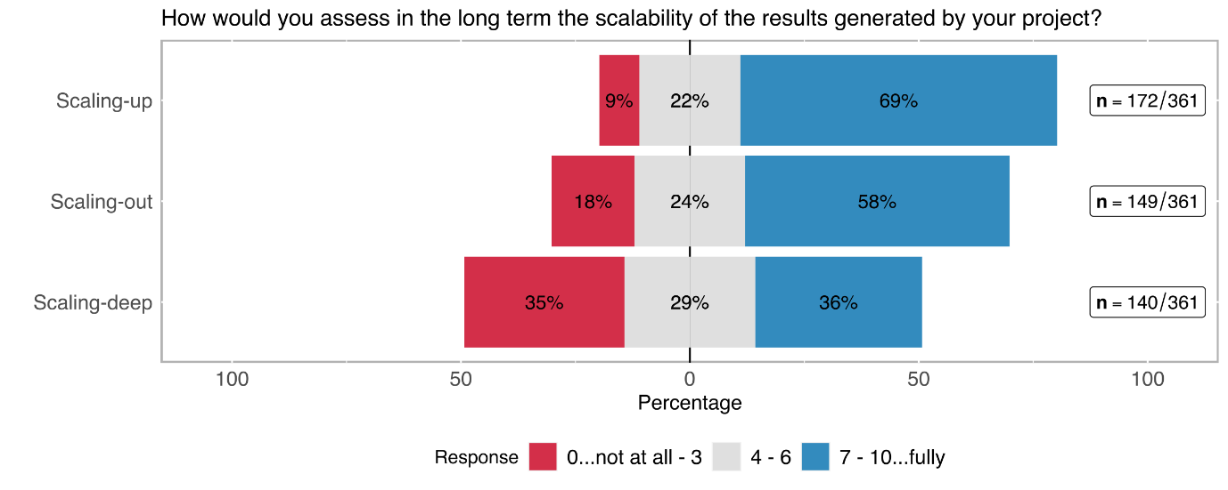

The scalability of the generated solutions to be applied in different contexts is another important goal in SI. 69 % of the respondents noted that the solutions generated throughout the project potentially have a high capability to be scaled up (cf. Figure 22 and Table 16), i. e. to achieve a higher impact if further used. The potential for scaling-out to different geographic areas was highly rated as well. This is hardly surprising, because most scientific research is not regionally limited but strives for universal knowledge and insights. Interestingly, 36 % of the respondents also think that their project results can potentially have a transformative impact in the sense of changing cultural and social values (scaling-deep).

Table 16: Types of scalability

|  |  |  |  |  |  |  |
| --- | --- | --- | --- | --- | --- | --- |
|  | **Scaling-up (to achieve a higher impact) (n=172)** | | **Scaling-out (to different geographic areas) (n=149)** | | **Scaling-deep (by changing cultural and social values and practices) (n=140)** | |
| **response** | abs | % | abs | % | abs | % |
| **0** | 3 | 1.74% | 11 | 7.38% | 17 | 12.14% |
| **1** | 4 | 2.33% | 6 | 4.03% | 12 | 8.57% |
| **2** | 2 | 1.16% | 7 | 4.70% | 10 | 7.14% |
| **3** | 6 | 3.49% | 3 | 2.01% | 10 | 7.14% |
| **4** | 6 | 3.49% | 5 | 3.36% | 13 | 9.29% |
| **5** | 21 | 12.21% | 25 | 16.78% | 17 | 12.14% |
| **6** | 11 | 6.40% | 6 | 4.03% | 10 | 7.14% |
| **7** | 36 | 20.93% | 24 | 16.11% | 16 | 11.43% |
| **8** | 38 | 22.09% | 33 | 22.15% | 15 | 10.71% |
| **9** | 10 | 5.81% | 5 | 3.36% | 5 | 3.57% |
| **10** | 35 | 20.35% | 24 | 16.11% | 15 | 10.71% |

## Exploitation and Utilisation

Exploitation and utilisation activities can be roughly divided into activities with the goal of commercialisation and activities with the goal of education and knowledge transfer.

**1. Commercialisation**

* **Company/Start up:** In particular, three projects from the natural or technical sciences tried to exploit their projects by founding a company or a start-up to translate their research into a product ready for the market. The founding process requires a lot of funding and a lot of commitment from partners with different expertise and skills. The companies could gain either additional public funding or attract investors. Many partners from the original projects were also involved in the companies or start-ups. These companies were in different phases at the time of the interview; one company was at a point briefly before bringing their first product into the market; one company was in the set-up phase; one company was already dropped after two years of existence. In other instances, founding a company to exploit the research project was considered, but the researcher then decided to stay in academia and draw funding from academia and leverage the existing university infrastructure, e.g., in the form of grants.
* **Patenting:** Patenting is seen as an important tool for technological transfer and to find industry partners for further development, in particular in the fields of pharmacy/chemistry and technology. Projects in these fields can result in several patents, which do not necessarily result in a product.
* **Further tests in practice context:** For some researchers, one goal of exploitation was to recruit a practice partner (e.g., a company, political administration) to further test their research in an applied context and better estimate the potential of their approach for impact in the real world. This can be seen as a natural next step for their research, allowing them to both further their scientific investigations and challenge them in the practice context.

**2. Education and knowledge transfer**

* **Consulting:** In general, only one project involved consulting companies as part of the exploitation activities, applying the knowledge gained in the research. Importantly, in this project, the company was already involved in the proposal and implementation phase of the project.
* **Online Courses/ MOOC and further training:** Some of the projects’ results could be used for further education aimed at practice partners, in the form of online courses, training (e.g., for teachers), developing curriculum modules and workshops. These formats were used as a form of knowledge transfer into the practice field.
* **Developing guidelines:** In addition to consulting and courses or training, developing practical guidelines and principles for organisations and institutions was another form of knowledge transfer.
* **Creating a database/publishing materials:** In one research project, a database systematising and preparing the material used in the project for a general audience; this could then be used by students or other researchers.

**Sustainability**

Usually, researchers have previous experience and previous research in the field of the SNF project, meaning that the projects are linked, and each project builds on the previous one. The researchers are often very familiar with practice partners working in the same field. They have already engaged in transfer or exploitation activities in previous projects on the topic and engaged different relevant stakeholders. They have built partnerships and collaborated with both academic and practice partners. Therefore, it can be difficult to distinguish the projects and collaborations that followed because of the SNF project from the ones that followed because of the researcher's general activity in this field of research.

**1. Follow up projects:**

* **Pure research projects:** Based on research findings, methods or products developed in the SNF projects, some follow-up projects dealt with expanding on the results, applying the methods in new contexts, overcoming limitations, or investigating open questions that remained. Often, these were conducted with some of the same academic partners of the SNF project or with PhD students from the SNF project now in new positions. Follow-up projects also emerged with new partners from other academic institutions working on the topic. In some instances, the PIs themselves were not involved in the follow-up project, but it was led and advanced by a former PhD student or Post Doc. In one instance, ideas for a follow-up project also resulted from exploitation and communication activities, whereby the researchers were confronted with feedback from practice, which gave new perspectives and impulses on the topic. In another case, the impulse to continue with a follow-up project came from the patients that were involved in the study. Many smaller follow-up projects were financed with internal funds of the respective university, which also served the purpose of examining the results for the readiness of exploitation and perhaps commercialisation. Most often, the funding for follow-up projects stemmed from internal funding or other funding schemes. Hence, almost no projects used additional SNF funding was used for follow-up projects.
* **Research projects with access/involvement of practice partners:** Some of the follow-up projects dealt with a similar topic as the SNF project did, but were able to gain access to new stakeholders and practice partners and involve them in the project, which promises new avenues and opportunities of achieving impact beyond academia. There was also a follow-up project that combined research and practice by transferring the results from the SNF project to other applied contexts and develop guidelines for the responsible institutions. One researcher participated in an art exhibition where he contributed an installation based on the research project. Efforts were also made to involve industry partners or private foundations in funding to enable a follow-up project. Again, these follow-up projects were mostly funded by internal finances of the researcher’s institution or private foundations. Only one follow-up project was funded by the SNF.
* **Practice/applied projects:** More applied follow-up projects were often funded by Innosuisse. Accordingly, many researcherssubmitted to Innosuisse to enable the technological transfer of projects results that were gained during the SNF project. In some cases, follow-up projects were taken up by industry partners, in which tools and applications are further developed based on the research outcomes.

**2. Further collaborations with project partners:** In more than half of the projects, the collaboration with companies that were already interested and involved in the project during the project implementation phase was continued after the official project end. In other cases, further collaborations with national and international academic partners, like submitting proposals for new projects, publishing papers, setting up labs, and working together on projects on different topics, were reported.

In some fields (e.g., education, medicine) the researcher and the academic partners are already connected through their institution; so, medical researchers and doctors are both involved at a university hospital, or researchers in education science do their research at the same institution that trains future teachers. The institutional connection between research and practice increases the exchange and collaboration between the partners and enables ongoing communication.

**3. Contact with practice partners after the end of the projects:** Many researchers are still in contact with their respective partners and contacts from practice, despite the project's end. This contact consists of exchanging new work or papers. Some researchers work at institutions that regularly interact with other practice institutions and foster student and employee mobility, often with the prospect of continuing the collaboration in a potential new project.

Importantly, researchers do not stay in contact with all of their practice partners; it is rather just a few selected contacts. But if they found an interested and engaged practice partner during the project, they will try and stay in touch and try to exchange ideas and knowledge in the future. They see the contacts that emerged during the SNF project as an opportunity for networking and enlarging their network to come back to it when a new potential project or other chance for collaboration arises, to again gain access to the field and relevant stakeholders. Oftentimes, the contact between academic and practice partners had already existed before the project started because the researchers have been active in the same field for years and have built expertise. Then of course, these contacts are ongoing after the SNF project has ended.

**4. Other long-term benefits of the project:** Another benefit in terms of sustainability is that researchers can increase their prominence and name recognition within the scientific community, but also among relevant stakeholders from practice and industry.

1. the last miles ON THE ROAD TO IMPACT

### Barriers and challenges in exploitation and utilisation

Not only the dissemination as discussed in chapter xx but also the exploitation of project results is crucial to achieve broader impact. However, interviewees identified several barriers when it comes to the exploitation and utilisation of their project results:

1. **Commercialisation:** Some researchers experienced difficulties in achieving the commercialisation of a product. Accordingly, product development often requires certification and additional administrative steps, which is often not perceived as worthwhile. One PI mentioned that the commercialisation of project outcomes is basically a different job, while others stressed other limited time they have for such activities. Additionally, oftentimes product development and making it ready for market entry requires a lot of money, predominantly from investors, and collecting money from investors requires a company. In some cases where commercialisation was a goal of the researchers, they found it difficult to find industry partners with whom they could commercialise the product; industry partners often do not want to work together with academic partners because their research, materials and code are often open access, which is detrimental for the companies' goals.
2. **Time:** After a project ended, researchers need to tend to other research projects that are funded, to teach and present at academic conferences; they have no time for exploitation and utilisation activities once the project is finished. Bigger endeavours like founding a company or start-up require even more time, especially since researchers’ companies often need to compete with other, already established companies in the market.
3. **Funding:** Project funding is limited to the typical three to four years, and a project is considered finished when the results can be presented and not when the results are disseminated or exploited in an applied context. This means that mostly exploitation and utilisation work has no funding dedicated to it, which limits the work researchers can do in this area. Funding could be in the form of a follow-up study (e.g., whether a specific technique is now really used by practitioners) or a dedicated exploitation project. Existing funding schemes are not considered as exhaustive in this regard, as, for example, Innosuisse requires existing support of the industry and having business partners, though part of exploitation work would be to find and recruit these partners.
4. **Administration and organisation:** Three researchers expressed that administration and organisation posed a challenge to their exploitation and utilisation activities. These consisted of issues with resubmitting to the ethics committees because of small changes in their project, which took very long as the committee only meets once a month, leading to delays; the administrative body of their university changed periodically, meaning changing support for their project and their ideas, delays of receiving the funding due to specific legal provisions.
5. **Raising awareness about the project and its relevance:**

* **Among the general population/ the public:** Some research topics are associated with already existing opinions or stereotypes in the general public, which makes it difficult to communicate their importance and relevance and to raise awareness.

*“I mean, the general impression is that it is a little bit difficult from general population to understand how severe is the problem. Actually, […] is mostly interpreted by the general population as something to do with wellness, not with medicine, and so this was difficult for us to let them understand that we are talking about a disease.” Interviewee 14*

In addition, it is experienced as difficult to abstract the research project to information and conclusions relevant to the public and to communicate the relevance and scientific achievements.

* + **Among policy makers and responsible institutions:** Communicating and implementing change based on research findings can be difficult if policy makers or the responsible institutions are not willing to fund this change, if it is too costly, or if the conclusions based on the research findings would not lead to immediate changes and impacts. Accordingly, one researcher stressed that decision-makers lose interest if results take too long to be implemented and change is not noticeable immediately.

*“They would use our results immediately like that, it is always the same - if nothing happens, no one cares.” Interviewee 12*

1. **Limited networking and exchange:** To achieve exploitation and utilisation of the project results, it would be important to further national and international networking, exchange, and collaboration – specifically between researchers but also with practice partners, including industry and business partners. Researchers often mentioned that limited exchange and collaboration between, e.g. the German-speaking countries, with other researchers, but also representatives from governments or civil society posed a challenge to the exploitation of their project. In particular, it would be helpful if there were more structural or institutionalised exchanges, like in the form of scientific centres which foster interactions between different disciplines, universities, or countries.
2. **Limited support or coaching:** Though most researchers stressed that they receive support from their organisation in pursuing exploitation and utilisation activities, three researchers voiced that the limited support or coaching from their organisation posed a challenge to the exploitation and utilisation of their project. While there are not explicitly hindered, they do not receive support and are seen as outsiders with their research. Or they lack a specific person or position at their institution which would support them in the next steps of applied work and impact in practice. Or they are left alone with applied and translational work, and have to do it on their own.
3. **Limited opportunities to continue projects:** Many researchers stated that it is difficult to exploit and utilise their projects without formal opportunities for the continuation of a project. Many ideas, questions, and conclusions only emerge towards the end of the project, and there is no opportunity to follow up or deepen these ideas and avoid wasting expertise and know-how. Researchers suggest that funding agencies like the SNF should actively encourage project continuation as part of a grant or as part of a new track so that these potential new insights can be captured. This kind of funding could focus on a follow-up study, on finding out whether results were taken up, or could just focus on dissemination and science communication to inform the public and relevant stakeholders, for instance, by preparing results for different audiences and travelling to different institutions, bodies, and organisation. In particular, PhD students would benefit from such a funding scheme endorsed by a funding agency like the SNF, as they basically lose their job with the end of the project. Such a funding scheme would be helpful for exploiting their research work. It would support those researchers who are forced to always be involved in a project in order to get paid.
4. **Difficulties in engaging the relevant stakeholders:** When trying to communicate results and make them usable, some researchers experienced that their target group of stakeholders, e.g., policy makers, simply was not interested or developed other priorities in the meantime. They did not come to presentations they were invited to, and hence, in-depth discussions of the topic couldn’t take place. In addition, stakeholders from practice often have difficulties with interpreting scientific results for their practice; they rather want suggestions for concrete actions, generalisability and general statements, need the information to be translated with regard for relevance for their own work
5. **Difficulties in communicating concrete conclusions:** Some researchers find it difficult to communicate concrete conclusions or suggest concrete actions for applied or practice contexts, which makes actual exploitation of the project results difficult.
6. **Difficulties in achieving social impact:** Some researchers expressed difficulties in really achieving social impact with their project, which is a problem within academia as a whole. There is often a lack of continuity of one project, one research team, or in the composition of institutional bodies, which means that interests and priorities change a lot, which prevents one topic from being really implemented and being turned into an applied project. Achieving social impact would require a more structured and sustainable way of exploitation and utilisation of a project. In addition, the novelty of project ideas is highly valued in academia, which means that a new project should not be a follow-up or applied project of a previous one but should deal with a new and innovative topic. However, it would be this continuous engagement with a topic that would be beneficial to achieve long-term social impact.

Overall, academic research has too little application orientation to make exploitation/utilisation easy – this is a difficulty specific to basic research (the nature of basic research). SNF grants similarly usually do not include application orientation or efforts for transfer and translation. In addition, efforts for exploitation or knowledge transfer are usually not rewarded in an academic career – publishing in scientific journals is the foremost goal of researchers.

1. **Limited knowledge if results are taken up:** Many researchers cannot assess whether their exploitation and utilisation activities were successful because they do not know the extent to which their results and conclusions were taken up by practice partners. Even if they held presentations and communicated with specific institutions, they have limited knowledge of the uptake as they were mostly not contacted afterwards and did not know how widely the results were disseminated. Finding out to which extent results were taken up by practice would require a follow-up study, as this question is out of the scope of the SNF research project. In addition, the researchers do not see themselves in the responsibility of making sure results are taken up – in the end, stakeholders, policy makers, practitioners, and representatives from responsible institutions have the responsibility of making use of the results and of investing in their realisation.

## Practice partners

In order to understand which impact the projects have had outside of academia, we interviewed nine practice partners. In general, the practice partners were associated with administrative offices, civil societies, or welfare- or education-providing institutions; some of them were explicitly in the role of providing a linkage between research and practice at their institution or had a scientific background supporting them in their practical role. Their roles at their institutions can be described as project managers, contact persons, supervising the project implementation at their institution, consulting partners, or experts.

### Motivation and social purpose

The motivation for practice partners or their institutions to participate in the projects was that the research project addressed some sort of problem or research questions the practice partners experienced as a problem in their own work. Accordingly, they hoped that the research could not only address this problem but also contribute to a solution and that they would benefit from their participation.

Specifically, their motivations were:

* The project can provide stimulating discussion and new insights. Research projects often bring together people with different expertise and knowledge, whether it is in the project team or by organising events or conferences. One practice partner expressed that a stimulating exchange with different partners was important, where new information is discussed.
* Because they are interested in the topic and content and want to **know** the results.
* Because they are interested in the topic and content and want to **use** the results in their practice: Practice partners hoped that the project results would be transferable to their practice and could be applied as solutions for perceived problems, as well as for future evidence-based decision making. They required an effort in knowledge transfer from the researchers and wanted to implement the results.

With the results and knowledge transfer from the research project, practice partners also hope to improve their own work and practice:

* Because they hope it will raise awareness about the issues and challenges they experience in their practice.
* Independence from the industry: One practice partner explained that by participating in the research project, he could learn and develop new strategies for practice and keep their independence; in contrast, collaborating with a research firm from industry would create dependencies and might influence the project, its results or the communication of results.
* Because there is a need for data and a research gap in their field of work.
* Because they feel like there are issues in their field of work and they hope that the research project can identify and promote a need for action.

It is crucial to note that a few researchers were also involved with practice partners from industry and business. Accordingly, stakeholders from industry might have very different motivations than actors from non-profit institutions. However, most practice partners said that a social purpose was an important part in the project. Social purposes that were identified were:

* Improving clinical practice
* Change among responsible institutions (e.g., public administration, welfare- and education-providing institutions)
* Awareness raising
* Improving care and situation in hospitals

### Impact and change for practice partners

Overall, there seems to be limited change in the partners’ everyday practice. Many of the practice partners seem to have already thought about the issue of the impact of the projects. One practice partner mentioned that he talked to his manager after the collaboration to reflect on the change the project had and could have had. Accordingly, he claimed that while his team had high expectations, the project did not create change within the organization. However, there was impact and change on the level of dissemination, understanding and awareness.

1. **Feedback:** For most practice partners, it is a positive experience to get feedback and insights from people like researchers, who come from a different field of work and have a different perspective on their practice work. Positive feedback supports and strengthens the practice partners confidence in their work.
2. **Engagement of different target groups and stakeholders:** Generally, several interviewees said they appreciated that the collaboration with academic partners also enabled the exchange with other actors. Two practice partners reported that they organized conferences together with their academic partners in order to facilitate exchange between practitioners and scientists. While this exchange was perceived as meaningful, both interviewees said that it did not result in greater impact or change.

*“Little, little. We took note of that, and of the results. We had / there was another exchange. We organized a conference between practice, administration and science, where we also discussed with people from the school practice what they think of the findings, but I would not attest to a lasting effect here.” Practice Partner 1*

1. **Dissemination:** Half of the practice partners said that the project had a positive effect on the dissemination of their organization’s goal. Correspondingly, one interviewee said that the cooperation with academic partners advanced the organization’s goal by raising awareness amongst policy-makers and the broader public. Similarly, another practice partner said that she experienced a slight change in the narrative surrounding her organization, both in the political as well as public discourse.
2. **Increased research activity:** Another aspect that was expressed by two practice partners is the increased knowledge through expanded research activities. Accordingly, the exchange with researchers allowed the accumulation of knowledge, which resulted in more interest in issues at stake for the practice partners. Further, one interview partner said that his organization and, more general, his field, benefited from the project as several doctoral students wrote their dissertations on the issues the organization is dealing with.

*“Indirect further effects are of course that we have these researchers who did their dissertation there, because that creates know-how, that's actually / that was an important goal on the part of the [organizsation], that's why we're now launching a similar project again, because we simply need research on the subject, we need people who acquire competences, and that's also been successful in parts.” Practice Partner 1*

### How can change and impact be facilitated?

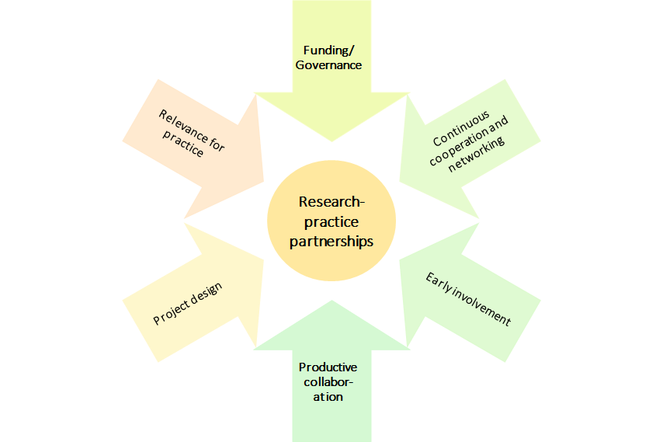

As change relevant for practice partners was limited, interviewees identified seven ways to enhance the impact of project collaborations.

1. **Transfer from academic to practical knowledge:** First, seven practice partners mentioned the limited use of academic knowledge for the “practical world”. One interviewee, for example, stressed that the “distance between practice and research is huge”. Respectively, many projects were not designed to also fit how knowledge outside academia is accumulated and hence, findings could not effectively be translated from academia to practice.

*“And of course, we asked the question a few times, how do you transfer this knowledge into practice […] because the project is very descriptive, and rightly so, but the question is, how do you then get a kind of practical transfer from these very descriptive results without too much structuring" Practice Partner 2*

Hence, in order to facilitate this transfer, projects need either an explicit design to enhance collective knowledge creation at the early stages of the project or clear dissemination and strategies which aim to facilitate this transfer. Another way to ensure the transfer of knowledge is to refer to support from intermediaries or knowledge brokers.

1. **Long-lasting collaborations:** Three practice partners reported that there was no contact with academic partners beyond the project end. However, all of them noted that further exchange could have promoted impact as long-term change cannot be achieved within a few months or one year. Thus, long-lasting collaborations and continuing exchange between academic and practice partners can enhance the impact. Additionally, such future collaborations could be facilitated by specific programmes or funding schemes. However, they should also be designed flexibly, allowing both parties to bring in their knowledge and resources.
2. **More dissemination and networks with other stakeholders:** A few practice partners reported that they would have wished for more dissemination of the project results and raising awareness of the role of practice partners. It was also highlighted that although there were some dissemination activities, they did not go far enough and failed to implement change. Moreover, missing networking was identified as a barrier to change. One interviewee, for instance, said that he would appreciate a platform that makes research available and connects researchers and practice partners.

*“Such vessels are extremely helpful in terms of networking, well, you know it keeps coming, and that's easy / that's why we are also a bit independent of the research interest or the research question interested in staying in touch, because we do exactly that, that it also comes together to form one, a bit of an overall picture and that we also we know where we might be able to fall back on research results when the opportunity arises.” Practice Partner 3*

1. **Increase relevance for practice:** A few practice partners also mentioned that academic research is often focused on theory development rather than addressing issues that concern practice partners. Accordingly, they cannot find relevance to their works in most academic research. In order to increase the relevance of academic knowledge for practice, practice partners could be included in the project early on in order to share their perspectives.
2. **Develop mutual goals and questions:** Similarly, it was stressed that there were no common goals within the collaboration framework which lowered the motivation of practice partners as well as their scope for action. One interviewee said that he had the feeling that the transdisciplinary approach rather benefited the researchers (e.g. because it was necessary to generate funding) but did not sufficiently include the interests of the practice partners. Hence, partnerships between academic and practice partners need to address the needs and goals of all partners.

*“We sometimes have interests, but the exact research question or the central interest of the research sometimes doesn't fit, and if it could only be slightly adapted it would sometimes be more useful for us, like that. That's the way it is, that's a theoretical assumption, but we sometimes see in projects where it's possible to get involved a bit earlier, that you can also give them add-ons that can then be used and are more useful to us.” Practice Partner 4*

1. **Intentional transdisciplinary design:** In addition, the involvement of practice partners could be increased within the projects. Correspondingly, an explicit framework that allows for mutual decision-making and mutual research activities could enhance the impact of collaborations. Contrarily, fixed and stringent ideas and presumptions should be avoided. Moreover, one interviewee partner said that research activities should be better tailored to the organizational context rather than designed beforehand.
2. **Foster bottom-up processes:** Two practice partners mentioned that the impact of the project was limited because the systems they operate in do not allow bottom-up processes. Accordingly, decisions are made on the top end of the “hierarchy”, which neglects the knowledge and experiences that are generated by people operating on the lower end of this hierarchy. Hence, researcher-practice partner relationships could benefit from institutionalised structures that also foster the implementation of project and innovation activities.

*“Yes, it's difficult to say from the bottom up, because change is very difficult there. Of course, it would have to be rinsed from the bottom up, so there would really have to be problems in practice, which would have to be passed on upwards, which would ultimately have to be changed politically.” Practice Partner 4*

### Interactions with academic partners and challenges in these interactions

1. **Proposal phase:** Three interviewees reported that they interacted with academic partners during the proposal phase. However, these interactions played out very differently in all three cases. In one case, the exchange during the proposal phase was limited to some informal exchanges and some preliminary networking in order to ensure collaborations during later stages of the project. One interviewee reported that he experienced his role rather as a consulting role. Accordingly, he met twice with the research team to give some insights into his role and provide some ideas for the proposal. However, he said that the communication was rather restricted and did not have vast effects on the proposal development itself. The last practice partner who was involved in the proposal phase was able to contribute significantly to the writing of the proposal. Correspondingly, the practice partner said that he met several times with the research team where they “put backgrounds together and developed the project together”.

In general, in-depth exchanges with practice partners were missing during the proposal phase, which in some cases also limited the impact of further interactions. In order to increase the impact of such cooperative interactions, exchanges should ideally start at an early project phase as it allows for mutual trust-building and knowledge transfer. Questions that could be answered during this phase could be:

* Why and how is this issue relevant in practice?
* How can practice partners be involved in the later stages of the project?
* How could results be used in practice?

1. **Implementation phase:** Almost all practitioners reported exchanges with their academic partners during the implementation phase. There were three modes of interaction:

* **Discussions:** Four interviewees said that they engaged in regular discussions about the project state with their academic partners. While they were not directly involved in the gathering of data or the implementation of the project, they gave continuous feedback and researchers updated them about the progress. While one interview partner said that the interactions were sometimes bumpy due to misunderstandings or conflicts, most others said the discussions went very smoothly:

*“[…] it was always very uncomplicated and quick, so I could really send an email if I had questions, or if it was more complex, I could call and either it could be solved immediately, or an appointment was made for a meeting, and, yes, that was all that was necessary, so it was well supervised, you had your contact persons, and in the end it was a bit of a self-runner.” Practice Partner 3*

* **Exchange about results:** Others said that their exchange with academic partners was limited to the exchange about project results. Additionally, practitioners stressed that this partly resulted in limited usability of the results for practice since the generation of outcomes was “a one-way street rather than mutual effort”. While this was sometimes the case because researchers did not make or have time for deeper exchanges, one interviewee stressed that he had limited finances in order to participate in more meetings:

*“I think I have to say that the exchange in the whole project, that is, between the whole project and me, individually, decreased a lot at the point where I simply no longer had a role, I had no finances.” Practice Partner 6*

Hence, in order to enable practice partners to effectively contribute to the project, funding could be provided.

* **Productive collaboration:** Two practice partners highlighted that they were intensively involved in the implementation phase. One of them reported that he supported the researchers with the development of a questionnaire and subsequently with the collection and interpretation of the data. The other practitioner helped the project team with the recruitment of participants and also supported the team with the analysis of the results. Both interview partners stressed that this extensive collaboration enabled them to bring in their perspectives as well as to use the knowledge in practice.

1. **Exploitation phase:** Half of the interviewees reported exchanges during the exploitation phase. These were either:

* **Informal meetings:** Two practitioners said that they frequently met with the researchers during the dissemination phase. These meetings were mostly informal and involved discussions regarding the usability of the results. These informal meetings also fostered the personal relationships between the researchers and the practitioners, which increases the probability of future collaborations.
* **Presentations:** In some cases, the researchers presented the project and its results at meetings with the organizations where either the practice partners or additional people from the respective organization were present. While this was highly appreciated by the practitioners as well as their managers, it often did not go further in terms of future contact and cooperation.

*“We see the motivation and the efforts of the producers, I would say now, to make their research tangible, so they offer to come by, to present, also put it in context, for example. We see that. That's how it went in this case, and yes, but the contact remains relatively loose.” Practice Partner 7*

* **Conferences:** Three interviewees said that they either participated in or co-organized a conference with their academic partners. One interviewee emphasized extensive interactions during the dissemination phase. Correspondingly, he organized conferences as well as other formal events together with the academic partners which enhanced the relationships to other stakeholders as well as widened the impact of the project. Accordingly, conferences and congresses can enhance the impact of the project as they also allow for the participation of other stakeholders.

*“We went to this exchange conference and we said "yes, come on, no, let's take that with us, let's play with it in practice, let's try to make it concrete and make it tangible in our context".” Practice Partner 8*

Some interviewees stressed that their involvement in the project declined over the different project stages. Accordingly, one interviewee mentioned that he was included in the writing of the proposal as well as the collection of data, however, he felt like the communication was losing substance during the exploitation phase. While he attributed this to the lack of time and funding, he acknowledged that the impact could have been even bigger if he had been able to contribute to the exploitation phase.

### Benefits for practice partners

1. **Increasing knowledge:** While the impact on the practitioners’ work has been limited, many of them highlight the personal impact they gained from the collaboration. Accordingly, four practice partners highlighted that they gained remarkable knowledge from the exchange with academic partners since it allowed them to switch perspectives and get insights into research. One interviewee said that his work is so stressful that he does not have enough time to read every research article that might be interesting for him. However, by specifically working together with researchers who focus on his field, he had the chance to get insights into current publications and innovative work that is being done. Another interviewee underlined that he is still in regular contact with his academic partners, who update her on new research and findings that might be essential for her work.
2. **Building skills:** In addition to building up knowledge, practitioners also benefited from increasing specific skills relevant to their work. Correspondingly, two practice partners mentioned that they had the chance to work on their skills during the collaboration by having access to new data and new methods. Hence, these interviewees said that the academic partners provided them with resources that they could use to improve their skills and practices.
3. **Enlarging network:** One benefit that was mentioned by all practice partners is the aspect of an increased network. Researchers did not only collaborate with the practice partners alone but included them in their wider network. Thus, practitioners had the chance to interact with actors that are also relevant to their work. One researcher said that after the collaboration, he felt like the power relations changed from being very hierarchically to being more equally distributed. Accordingly, before the project, she experienced misunderstandings and a lack of interest from other stakeholders. This, however, changed when she had the chance to communicate with others and got the chance to point out the challenges in her organization.
4. **Contributing to change/impact:** Although the impact of the project was limited according to most interviewees, the opportunity to contribute to change was seen as beneficial for practitioners. Respectively, it was argued that despite the failure to achieve immediate structural change, practice partners had the feeling of being able to add to processes that can eventually lead to long-term change. This has two main benefits. First, one interview partner claimed that through being included in such a process, she felt empowered and heard since she had the feeling to be **w**orking with others on an equal footing. Second, one practitioner mentioned that he felt motivated to contribute to the creation of impact as he saw what can be possible when collaborating with others.

### Sustainability and exploitation

1. **Follow-up project with academic partner:** There was one follow-up project with the academic partner. The practice partner mentioned that due to the trust that was built during the first collaboration, both parties agreed to continue working on relevant issues. Accordingly, the academic partner was already planning to start another project and the practitioner was hence asked whether he wanted to be involved again.
2. **Follow-up project without academic partner:** One interviewee said that he could use the collaborative project as a starting point to work on a follow-up project with other partners. Accordingly, the project raised his interest in a new method, which was only sparsely touched upon within the project. Accordingly, he wanted to further develop this method with other stakeholders but also with his academic partner who unfortunately had no time to contribute to the follow-up project.
3. **Continuing contact with academic partner:** Three practice partners mentioned that they are still in touch with their academic partners. While one stressed that this contact is only very loose, the two others said that they still have meetings with their academic partners where they update each other on their work. Both of these interviewees said that they could imagine future collaborations again, but the situation has not yet arisen.
4. **Bottom-up dissemination:** Two interviewees said that they were able to disseminate the project results to upper levels within their organizations. Although both of them claimed that they could not achieve a broader impact, they had the feeling of being heard by the management level. Furthermore, both of them argued that the positive experiences from the projects increased the willingness of the managers to further support employees to participate in such projects.
5. **Discussions:** Three practice partners said that they were or are still in the discussion either with colleagues from their organisation or with other experts. While these discussions do not happen on a regular basis, they provide fruitful ground for future project ideas. Furthermore, one interviewee said that he was explicitly approached by another expert in his field because this expert heard from him because of the research project. Hence, participating in research projects also allows practitioners to widen their network apart from the academic partner.
6. WRAP-UP 1: VALUATION of social innovation as potential outcome category of SNSF funded research

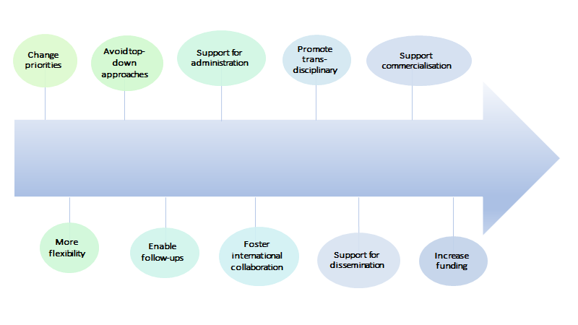The challenges discussed in the previous chapter as well as the manifold opportunities regarding the social innovation potential of SNSF funded projects show that there is sufficient leeway to increase the (social) impact of research projects. Hence, based on the interviews we identified ten areas of activity that can be seen as possible stations on the pathway to impact.

1. **Change priorities of universities:** Many researchers experienced support from their institutions in pursuing transdisciplinary and translational projects, both in terms of a supportive culture and concrete support offers like coaching. However, they also argued that the universities’ priorities are not actually social innovation or social impact but rather an outreach, communication/dissemination, and popularity. Implementation and achieving real impact are not perceived as the foremost goals. If researchers want to implement their results to achieve social change, they are expected to do that on top of their usual activities and not instead of those; this approach limits resources in terms of time and money. One way of refocusing these priorities and promoting applied and translational research is by teaching, in which students can be made aware of all the possible outlets and applications of science.
2. **Avoid top-down approaches:** Top-down approaches, in which a research topic and approach are defined by a call or grant which requires a specific composition of the collaboration team, are perceived as artificial and hampering social innovation; it is perceived as forced and restrictive. Rather, good science and productive collaborations will develop naturally if given time and space and will find non-traditional publication outlets for dissemination. Similarly, the top-down approach of defining standards or indicators based on which the impact of projects is evaluated is considered restrictive, as social innovation is a multifaceted concept, and there are various different ways of being innovative.
3. **More flexibility:**
   * **To involve a broader spectrum of disciplines and different fields (e.g., also from the arts) and allow funding for projects with different designs/rationales:** Transdisciplinary projects require flexibility to foster the involvement of non-scientists; this includes, on the one hand, creating space for non-scientists to approach the research project in their own way without forcing the academic definition of what research is, and on the other hand, to give space for different approaches and rationales in the research design. This increased flexibility could be achieved if the evaluation criteria are designed in a more adaptable way.
   * **To accustom different research fields, traditions and methodologies**: One part of the lacking flexibility is that the researchers tend to adapt their proposal not to what they think is innovative, relevant and reasonable but to what they think the reviewers will understand and approve and will not disrupt pre-defined review categories of research. But it is also acknowledged that the review of a transdisciplinary and interdisciplinary project proposal is not trivial, as it requires very broad knowledge and far-fetching understanding of different fields and applied contexts.

In addition, not all research fields fit into a straightforward planning scheme. Many directions in field work and exploratory studies only develop after the first investigations and research steps, and thus they cannot be planned ahead because they might change depending on new insights. Some researchers expressed the concern that currently, the methodologies and research traditions predominantly common in the natural sciences are forced onto humanities researchers, which restricts their research and their approaches. For instance, terms like “method” or “methodology” are seen as critical in the humanities, and research methods like experiments are irrelevant for a humanities researcher. But they still feel that their proposals and projects are evaluated based on criteria that do not apply to their fields and that their projects need to adapt to standards that hamper their research.

Accordingly, project funding schemes should adapt their evaluation criteria and open up the proposal process so that:

* + **To allow for goals other than publication productivity and to widen the evaluation of what a good project is and what research should be:** Research more generally, but also funding agencies like the SNF heavily incentivise publishing in scientific journals as the main scientific outcome. The priority in this is quantity. Implementation work is not considered for publication by scientific journals and thus does not provide value for researchers’ careers and evaluations.

Flexibility for different research designs and the involvement of different academic and non-academic actors could also be fostered if different outcomes would be encouraged. In addition, evaluation criteria of a project’s success are too much determined by the amount of funding, publications, and PhDs or Post-docs employed, whereas the contribution to theory, the progress of the field, or applications in practice is neglected.

*“[…] because the criteria for good science are: did you get money, did you hire people - it is the same as if you were managing a hotel or a company. […] but definitely, that is really not something I am proud of - I was stuck in this network of constraints and you just try to survive.” Interviewee 14*

* + **To change directions during the project if new ideas for research strategies or insights arise:** Overall, flexibility in changing research directions during the project if new findings arise was wished for.

1. **Support for administration and flexibility regarding bureaucracy**: The administrative part of project planning and implementation can pose a challenge during the project, which might hamper the extent to which it can be exploited for social change. Researchers wish for more flexibility and support in the administrative process, which can be difficult, in particular in clinical research projects or other projects researching living subjects where specific ethics protocols need to be fulfilled. The administration is increasingly perceived to be overbearing and diminishing the freedom and flexibility of researchers. The SNFS and other funding agencies could provide a service to support scientists in handling administrative aspects of project proposals and project implementation. Also, flexibility in financing and funding could encompass extra time and money for individual cases.
2. **Enabling and encouraging project follow-up and prolongation:** As discussed in the previous chapter, the three-to-four-year framework of project work can hamper social innovation, as it does not allow for enough time to disseminate, follow up with practice partners, and further investigate new questions or ideas that developed during the project. Accordingly, there is an issue regarding the fundamental way new proposals are evaluated; there is too much focus on the novelty of the topic and approach, compiling a new project team, and doing something different than before. At the same time, the academic career requires researchers to swiftly jump from one project to the next in order to be funded, which leaves little time for project dissemination and exploitation. However, implementing change and achieving impact is a long-term process that requires stability and continuity.

This issue also reveals a fundamental contradiction between the concepts of scientific innovation and social innovation. Practices for achieving scientific innovation include frequent change of project members (such as PhD students), frequent change of topics and research questions, and novelty. However, practices for achieving social innovation include long-term knowledge and capacity building as well as continuous efforts for communication, dissemination, and relationship building among stakeholders and practitioners.

*“This whole funding and application policy is actually somewhat at odds with the ability of research, to research social innovations, to accompany them, and actually to accompany them in such a way that the other actors then also notice how important the research is by seeing the continuity and seeing the knowledge build and not seeing - now a graduate student comes along and now another graduate student comes along and so on.” Interviewee 9*

*“You have funding for three years, and then within three years you start the same project again? So this is not original! That's not new!’ Whether it's articles or research projects, I've had this kind of remark very often.” Interviewee 15*

There are different ways of designing opportunities for prolongation and follow-up. Suggestions expressed by researchers can be situated on two levels:

* First, on the level of the funding scheme: funding schemes could include a fast track to apply for funds, for instance, to develop a market-ready product, or a funding instrument specifically for implementation and transfer work, which funds one or several applied follow-up projects.
* Second, on the level of the project, which relates to different phases of the project. In the proposal phase, it could be required or asked that proposals already include a plan or concept of project exploitation. In addition, calls for proposals could encourage longitudinal research designs, in which the same people are followed and investigated over a longer period of time to better capture changes. Towards the end of the project, SNF could allow for or plan three to six months of extra project time devoted to dissemination, communication and exploitation of results.

*“Our daily routine is that when the SNSF money runs out, we have to land the next one and have relatively little time to continue working on the project, although there is no point in stopping there. There are other logics at play here. If only the SNSF were to add a buffer so that the results could be distributed even more widely.” Interviewee 22*

*“But that you would then have another six months, perhaps, to really speak to various organisations, bodies, institutions, and perhaps also to prepare the results in a slightly different way, in addition to articles or monographs, so that you could also better bring them to the people, that is simply not possible within a project.” Interviewee 23*

1. **Foster structures/systems/institutions for internationalisation and collaboration among researchers:** Some researchers also stressed that international networks and collaborations are essential for creating impact. One way this could be achieved is by creating and fostering a network of European scientists where Switzerland takes on a prominent role so that Suisse scientists will also be able to join European coordinated projects. Other PIs also mentioned the possibility of creating more National Competence Centres for collaboration on big, important topics.
2. **Promote transdisciplinary work:** Overall many researchers expressed interest in systematically connecting research and practice by promoting and engaging in transdisciplinary projects. In particular, this should not be left on the shoulders of the individual researchers who then have to do that on top of their usual academic work, but it should be systematically enforced by institutions such as the SNF and universities. The promotion of transdisciplinary work is seen as vital to achieve social impact and, as such, to achieving social innovation – it could take different forms:
   * **Strengthen dialogue and transfer between research and practice:** Creating opportunities for connecting to strengthen the dialogue and transfer between researchers and relevant stakeholders from practice. Diversity is key here, as it is perceived as important to bring together people with different skills and profiles. Support could start by connecting researchers with relevant practice partners, such as policymakers so that their research can be disseminated and used by practice partners. For instance, the SNFS could use its reputation to actively promote funded projects among policy makers and practitioners and accelerate networking. Or could connect with applied experts from the university of applied sciences.
   * **Increase structured/institutionalised cooperation with and involvement of stakeholders:** Involving stakeholders, ideally from an early stage, is perceived as vital for achieving social impact and social change. This should go beyond simply sharing reports with results but needs to focus on active communication and knowledge transfer. Cooperations could also focus on jointly identifying problems and developing research questions so that the findings can be more readily implemented in practice and achieve higher impact. This could also be addressed by particularly supporting young researchers with a practice background or recruiting practitioners or people from the industry for coaching researchers. These cooperations with practice partners who can then also inform about the problems relevant to them and jointly develop solutions are what can foster social impact.

*“The interaction with the actors on the ground and the kind of expertise they bring up and thinking about how we should organise ourselves so that we can overcome certain barriers together, that's what I find exciting.” Interviewee 16*

*“But if you want to have an impact, you have to create a cooperation with these policymakers. You have to invite them to university, you have to make sure they understand what you are doing, […] and have a more proactive approach.” Interviewee 17*

Importantly, these efforts for cooperation and involvement should not be left on the shoulders of the researchers; rather, it is necessary to create structures or institutions that provide guidance and support already during project development and implementation.

*“If one of the ultimate goals of the SNF is to change society through science, I believe some centralisation is needed there - if we leave researchers by the task of doing that by themselves, that is fine, but they need some guidance, some audit, at least, during, not ex-post, like we are doing now, but during the project development.” Interviewee 17*

An example of support structures mentioned in the interviews are regional centres in which researchers and practitioners come together to exchange; researchers’ results can feed into these centres, while practitioners can receive support or training in scientific methods and in understanding scientific results.

1. **Support for commercialisation:** Five interviewees mentioned that they would have appreciated support in producing patents and protecting the researcher’s ideas. Moreover, general support for getting in touch or creating networks with the industry or relevant partners was seen as potential facilitators of commercialisation.
2. **Support in media work and science communication:** Support in overall media work would be appreciated, including marketing of ideas and products, marketing on social media, cooperation with journalists, and science communication with practitioners and the general public. Researchers often do not feel confident in dealing with media and are afraid that their ideas are incorrectly or inaccurately communicated. Some researchers had unpleasant experiences when cooperating with the media or journalists, whereby their statements were misrepresented or inadequately generalised to create a “catchy headline”.
   * **Marketing:** The development of marketing ideas that target the society and policy makers is perceived as helpful by many researchers. Many interviewees stress that marketing their research is very tiring - albeit necessary - especially as researchers do not have the time to do marketing on top of their research.
   * **Social media:** Some researchers expressed interest in getting support for the dissemination/communication of results on social media platforms because there it is possible for researchers to control their message so that inaccurate media reports or "catchy headlines” in magazines/newspapers are avoided.
   * **Science communication:** Researchers are used to communicating with other researchers about their projects and findings and can find it difficult to transfer the findings into a format interesting and relevant to the general public. In particular, researchers fear that their transfer work for communication could result in inadequate generalisations or misunderstandings of their findings. In order to support researchers with dissemination, experts in science communication could be consulted. These experts could help researchers in translating their insights and findings into an accurate but digestible version for communication in non-scientific areas and for the general public.
   * **Trustworthy journalists:** One researcher expressed that she would like the SNF to work together with journalists who are rigorous and trustworthy and who will cooperate with researchers to write about their findings. In this context, it is important that vulnerable or excluded groups are not misrepresented or exploited for the purpose of the article. It is also important that a long-term relationship with this journalist can be developed in order to build trust.

*“If that was a freelance journalist, for example, then, if I were to plan something like that again, then I had good experiences with her and then I would perhaps approach her specifically and say - could you imagine, perhaps under the conditions, to do so and so. And then the person would perhaps see where they could cooperate with which newspaper, for example. Then that would be the concrete support, I think, that you could work together with such an experienced person.” Interviewee 18*

1. **More funding:** In general, many researchers would wish for more funding:

* for involving and cooperating with applied institutions and practice partners
* for applied research projects
* for infrastructure, employees, equipment, conferences and events
* for time to write and higher quality writing of books or articles
* diverge more funding to social sciences and humanities

*“I am full of admiration, but there are billions for those who go to study the stars and non-billions for those who go to study individuals on Earth.” - Interviewee 15*

1. WRAP-UP 2: TOWARDS A MODEL OF ASSESSING snsf’ CONTRIBUTION TO SOCIAL INNOVATIONS

Our proposal aims to trace contributions of research funded by SNSF to social innovations, and to systematise these contributions in a valuation framework. In addition, we aim to identify to what extent contributions to social innovation in SNSF-funded research projects are possible at all, and where further support measures, either provided by SNSF or from outside (e.g. by the universities), could create an added value that could not be tapped so far.

1. LITERATURE

Antons, D., Grünwald, E., Cichy, P. and Salge, T.O. (2020), ‘The application of text mining methods in innovation research: current state, evolution patterns, and development priorities’, in R&D Management, 50: 329-351. https://doi.org/10.1111/radm.12408

Benneworth, P. (2015), ‘Tracing How Arts and Humanities Research Translates, Circulates and Consolidates in Society. How have Scholars been Reacting to Diverse Impact and Public Value Agendas?’, *Arts and Humanities in Higher Education,* 14 (1), 45-60.

Blei, D. M., Ng, A. Y., & Jordan, M. I. (2003), ‘Latent dirichlet allocation’, in Journal of machine Learning research, 3(Jan), 993-1022

Bonno, Pel et al. (2020), ‘Towards a theory of transformative social innovation -- A relational framework and 12 propositions’, in Research Policy 49.8 (2020): 104080

Bornstein, N, Pabst, S and Sigrist, S. (2014), Zur Bedeutung von sozialer Innovation in Wissenschaft und Praxis. W.I.R.E, Forschungsbericht erstellt im Auftrag des Schweizerischen Nationalfonds (SNF).

Brundenius, C. (2017), ‘Challenges of rising inequalities and the quest for inclusive and sustainable development’, in C. Brundenius, B. Göransson, and J. M. Carvalho de Mello, (eds*) ‘Universities, Inclusive Development and Social Innovation’*, Switzerland: Springer, 9 -69.

Cana, Umit and Bilal Alatas (2020), ‘A new direction in social networkanalysis: Online social network analysis problems and applications’, In Physica A: Statistical Mechanics and its Applications 535: 122372, doi: 10.1016/j.physa.2019.122372

Cunha, J. and Benneworth, P. (2013), ‘Universities’ contributions to social innovation: towards a theoretical framework’, paper presented at EURA Conference 2013, 3-6 July, Enschede, The Netherlands.

Davidovitch, N., and Eckhaus, E. (2018), ‘Effect of faculty on research cooperation and publication: Employing natural language processing’, in *Economics & Sociology* 11.4 (2018): 173

Dees, J. G. (1998), ‘The Meaning of Social Entrepreneurship’, Graduate School of Business. Stanford University.

Degelsegger, A. and Kesselring, A. (2012), ‘Do Non-Humans Make a Difference? The Actor-Network-Theory and the Social Innovation Paradigm’, in H. W. Franz, J. Hochgerner and J. Howaldt (eds), *‘Challenge social innovation Potentials for business, social entrepreneurship, welfare and civil society’*, Berlin and New York: Springer, 57-72.

Ferner, Cornelia, et al. (2020) ‘Automated Seeded Latent Dirichlet Allocation for Social Media Based Event Detection and Mapping`, in Information 11.8 (2020): 376.

Godin, B. (2012), ‘Social Innovation: Utopias of Innovation from c.1830 to the Present’, project on the Intellectual History of Innovation, Working Paper N. 11. Montreal.

Gök, A., Milosevic, N., Nenadic, G., Catalano, G., Daraio, C., Gregori, M., Moed, H. F. and Ruocco, G, eds. (2019) Using machine learning and text mining to classify fuzzy social science phenomenon : the case of social innovation. In: 17th International Conference on Scientometrics and Informetrics, ISSI 2019. International Society for Scientometrics and Informetrics, ITA, pp. 2171-2176. ISBN 9788833811185

Hellsten, I., Opthof, T. and Leydesdorff, L. (2020): N-mode network approach for socio-semantic analysis of scientific publications. Poetics, Volume 78. <https://doi.org/10.1016/j.poetic.2019.101427>

Howaldt, J. (2019), ‘New pathways to social change – creating impact through social innovation research’, *fteval Journal for Research and Technology Policy Evaluation,* 48/July 2019, 37-48.

Howaldt, J., Kopp, R. and Schwarz, M. (2015), *‘On the theory of social innovations: Tarde's neglected contribution to the development of a sociological innovation theory’*, Weinheim: Beltz Juventa. <https://nbn-resolving.org/urn:nbn:de:0168-ssoar-419633>

Howaldt, J., Butzin, A., Domanski, D. and Kaletka, C. (2014), ‘Theoretical Approaches to: Social Innovation. A Critical Literature Review’, a deliverable of the project ‘Social Innovation: Driving Force of Social Change’ (SI-DRIVE), Dortmund: Sozialforschungsstelle.

Howaldt, J. and Schwarz, M. (2010), ‚Social Innovation: Concepts, Research Fields and International Trends’, IMO International Monitoring. Dortmund: Sozialforschungsstelle, TU Dortmund University.

Li, X., Ouyang, J., Zhou, X., Lu, Y., and Liu, Y. (2015), Supervised labeled latent Dirichlet allocation for document categorization. *Applied Intelligence*, *42*(3), 581-593.

Lindstedt, N. C. (2019), Structural Topic Modeling For Social Scientists: A Brief Case Study with Social Movement Studies Literature, 2005–2017. *Social Currents*, *6*(4), 307–318. <https://doi.org/10.1177/2329496519846505>

Lizuka, M. (2013), ‘Innovation systems framework: still useful in the new global context?’, UNU-MERIT Working Papers #2013-005.

Moulaert, F., Mac Callum, D. and Hillier, J. (2013), ‘Social Innovation: intuition, precept, concept, theory and practice’, in F. Moulaert, D. MacCallum, A. Mehmood, and A. Hamdouch, (eds), *The International Handbook on Social Innovation: Collective Action, Social Learning and Transdisciplinary Research*, Cheltenham: Edward Elgar, pp. 13-24.

Murray, R., Caulier-Grice, J and Mulgan, G. (2010), ‘The Open Book of Social Innovation’, NESTA and the Young Foundation.

Novotny, H., König, T. and Schuch, K. (2019), ‚Impact Re-Loaded’, *fteval Journal for Research and Technology Policy Evaluation,* 48/July 2019, 8-9.

Nussbaum, M. (2010), *Not for Profit. Why Democracy Needs the Humanities.* Princeton: Princeton University Press.

Perotte, A. J., Wood, F., Elhadad, N., and Bartlett, N. (2011), Hierarchically supervised latent Dirichlet allocation. In *Advances in neural information processing systems* (pp. 2609-2617).

Pol, E and Ville, S. (2008), ‘Social Innovation: Buzz Word Or Enduring Term? Working Paper 08-09, Wollongong: Department of Economics, University of Wollongong.

Prüfer, P. and Rexroth, M. (2005), Kognitive Interviews. ZUMA-How-to-Reihe Nr. 15.  
<https://www.gesis.org/fileadmin/upload/forschung/publikationen/ge-sis_reihen/howto/How_to15PP_MR.pdf>

Ramage, D., Rosen, E., Chuang, J., Manning, C. and Mcfarland, D. (2009). Topic Modelling for the Social Sciences.

Reale, E., Avramov, D., Canhial, K., Donovan, C., Flecha, R., Holm, P., Larkin, C., Lepori, B., Mosoni-Fried, J., Oliver, E., Primeri, E., Puigvert, L., Scharnhorst, A., Schubert, A., Soler, M., Soòs, S., Sordé, T., Travis, C. and Van Horik, R. (2018), ‘A review of literature on evaluating the scientific, social and political impact of social sciences and humanities research, *Research Evaluation,* 27 (4), 298–308.

Roberts E. M., Brandon M. S. and Edoardo M. A. (2016), A Model of Text for Experimentation in the Social Sciences, *Journal of the American Statistical Association*, 111:515, 988-1003, DOI: 10.1080/01621459.2016.1141684

Schäfer, T. and Kieslinger, B. (2016), *‘Supporting emerging forms of citizen science: A plea for diversity, creativity and social innovation’*, Journal of Science Communication, 15(2), 1-12.

Schuch, K. (2019), ‘The contribution of social sciences and humanities to social innovation’, in J. Howaldt, A. Schröder, C. Kaletka, and M. Zirngiebl, M. (eds.), *Atlas of Social Innovation*, *2nd Volume: A World of New Practices’*, Munich: Oekom Verlag, 95-98.

Schuch, K. and Salamon, N. (2021), ‘Reflections on the presumably difficult relation between social innovation and social sciences‘, in J. Howaldt, C. Kaletka and A. Schröder (eds), A Research Agenda for Social Innovation, Edward Elger Publishing (forthcoming).

Shirk, J. L. et al. (2012). Public participation in scientific research: a framework for deliberate design. Ecology and Society 17(2). Spaapen and Drooge, 2011

Smith, Steven T., Edward K. Kao, Danelle C. Shah, Olga Simek, and Donald B. Rubin (2018), ‘Influence Estimation on Social Media Networks Using Causal Inference’, in IEEE Statistical Signal Processing Workshop (SSP), doi: 10.1109/SSP.2018.8450823

Stanley Wasserman and Katherine Faust (1994), ‘Social Network Analysis: Methods and Applications’, Vol. 8. Cambridge university press.

Wen, Sheng et al. (2015), ‘A Sword with Two Edges: Propagation Studies on Both Positive and Negative Information in Online Social Networks’, in IEEE Transactions on Computers, vol. 64, no. 3, pp. 640-653, doi: 10.1109/TC.2013.2295802

1. ANNEX

I. Fields/domains of interview partners

|  |  |
| --- | --- |
| **Field/Domain** | **Number of interviews** |
| Architecture and social urban science | 1 |
| Arts | 1 |
| Astronomy, Astrophysics and Space Sciences | 1 |
| Bioengineering | 1 |
| Biophysics | 1 |
| Computer Science | 1 |
| Economics | 1 |
| Education and learning sciences | 3 |
| Ethnology | 2 |
| General History | 1 |
| Geochemistry | 1 |
| German and English languages and literature | 1 |
| Humanities | 1 |
| Information Technology | 1 |
| Legal Sciences | 3 |
| Medical Microbiology | 1 |
| Medical Technology | 1 |
| Medicine | 1 |
| Molecular Biology | 1 |
| Neurophysiology and Brain Research | 1 |
| Neuroscience | 2 |
| Organic Chemistry | 1 |
| Other Languages and Literature | 2 |
| Physics | 1 |
| Political Science | 2 |
| Psychology | 3 |
| Social Sciences | 3 |
| Social Work | 2 |
| Sociology | 1 |
| Swiss History | 1 |
| Theology | 2 |
| Visual Arts and Art History | 2 |

**

**Getting in touch with the ZSI – Zentrum für Soziale Innovation**

Address:

Linke Wienzeile 246

1150 Vienna

Austria

Phone:

0043-1-4950442-0

eMail:

[*office@zsi.at*](mailto:office@zsi.at)

www.zsi.at

1. cf. *What is transdisciplinary research?* at <https://naturalsciences.ch/transdisciplinarity> [last accessed: March 2022]
2. To reduce the overall time needed to fill in the online questionnaire, filters based on responses to previous questions were used. This is an example of such a filter – only those participants would actually get to self-assess their project’s contribution to SI who were at least moderately familiar with the concept of SI (5 or higher).
3. An index based on a statistical model, both of which will be presented as part of the final report.
4. provide information via interviews, online questionnaires, etc.
5. consultative + contributing through collecting data, validating data, disseminating results, etc.
6. contributory + interpreting data and/or drawing conclusions
7. collaborative + participated in designing study and/or determining objectives
8. <https://www.merriam-webster.com/dictionary/practice>
9. <https://www.merriam-webster.com/dictionary/behavior>
10. e. g. women/men/non-binary, youth/elderly; migrants; or minorities/indigenous people
11. such as schools, kindergartens, hospitals, or care centres